Annex A

ILLUSTRATION OF
AIRSPACE FREED UP ARISING FROM THE REVISED SURFACES

Chart 1: Along the Runway

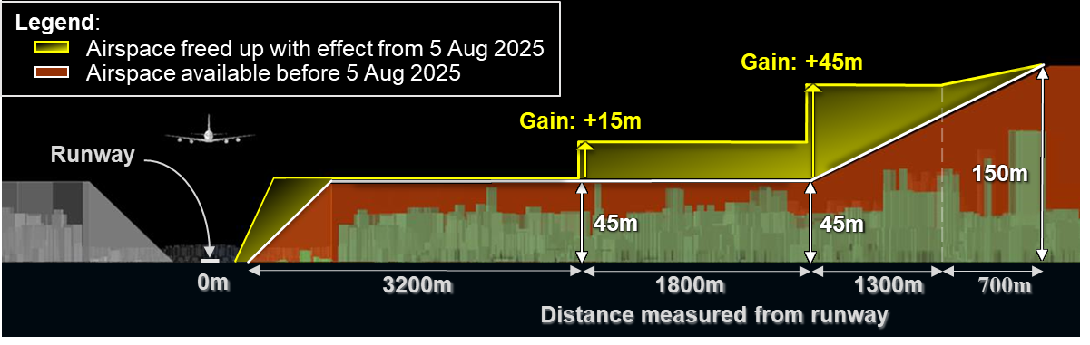

Chart 2: At the ends of the Runway

