Reg 33_Annex A

Impact Assessment Report
Regulation 33, Building Control Regulations
Project Title ____________________________________________________________
____________________________________________________________

Project Reference No: _________________________

Part I – Basic Information
1. List of properties that may be affected during construction is shown below:
I have advised Builder on the zone of pre-construction survey to be carried out before commencement of work in accordance with BCA’s Guidelines on Preconstruction Survey and have assessed that it is adequate for the proposed building works.

S/N | Address | Brief description of the property
1
2
3
etc

2. Site observation
I have identified the presence and assessed the stability of retaining wall, slope or boundary wall at site. Site photographs are attached in the report.

 | Location | Type | Height
Slope |  | -
Boundary wall >1.8 m high
Retaining wall

3. Type of building works to be carried out:

Please tick “” the appropriate boxes

Demolition | Piling, foundation
Excavation, site formation | Tunnelling, pipe jacking

Part II - Checklist on Impact Assessment Report

The report shall consist of recommendations on the preventive measures to be taken in connection with, but not limiting to the following types of construction work:

(Please tick “” the appropriate boxes)

Excavation or tunnelling work

Excessive ground settlement

Weakening of boundary wall/retaining wall/slope

Piling work

Excessive vibration or ground movement

Cracking of non-suspended slab, tiles, walls and structure

Demolition work

Excessive vibration

Water seepage into abutting property

Hacking work

Hacking of common continuous beams where the structural adequacy of the remaining continuous beams is affected (e.g. reconstruction of a unit of a pair of semi-detached house)

Removal of common roof canopy or car porch roof where the stability of the remaining canopy or porch is affected

Hacking of common footing (shared by two properties)

Other work (please specify)

______________________________________________________

Part III – Declaration

I confirm that I have carried out design analyses and impact assessment for building works stipulated in Building Control Regulation 33. Recommendations on measures to be taken in connection with the proposed building works so as to prevent any settlement or movement which may impair the stability of or cause damage to the whole or part of any premises or building adjacent or in otherwise close proximity to the building works are included in the impact assessment report. Detailed impact assessment report is attached or submitted under plan approval in ST______.

Signature & stamp of Design QP(ST) Date: ______________

Signature & stamp of Design QP(Geo) Date: ______________
(For GBW submission)
ERSS_Annex A

DESIGN CONSIDERATIONS FOR EARTH RETAINING OR STABLISING STRUCTURES (ERSS)

Project Ref:______________ Project Name:______________________________________________
(note : this form is to be completed and attached to the design calculations)
SECTION I (by the QP(D) and QP(Geo)(D) for GBW (please tick box when applicable)
1 | Key design considerations  I have designed ERSS in accordance with the building codes and regulations. I confirm that the ERSS design is structurally safe and robust. As a minimum, I have taken into account the following aspects:  - Adequate and appropriate site investigation;  - Proper evaluation and selection of the soil parameters for design in accordance with EC7;  - Effects due to onerous water pressures and seepage forces;  - Effects due to onerous soil loading conditions from both undrained and drained/time dependent soil drainage conditions;  - Effects of surcharge loads (at least 10 kPa), including incidental loads, construction loads, adjacent slope, load from adjacent existing structures and usage, etc;  - Varying load conditions during stages of the construction including removal stages;  - Design robustness and redundancy considerations including one-strut failure, accidental loads, unplanned excavation, etc.  - Adequacy of wall embedment against toe stability and seepage control, etc.  - Adequate factor of safety against overall wall stability and basal heave/hydraulic uplift/piping;  - Structural adequacy of wall and supporting system e.g. walers, struts, anchors etc. considering temperature effect and stiffeners  - Provision of continuous concrete packing between waler and wall, preloading of struts, adequate stiffeners and temperature effect;  - Design for adequate effective length of kingpost and struts considering construction sequences;  - Effects of ground water lowering and ground deformation on neighbouring properties;  - Factor of safety for the design shall not be less than that for permanent works.
_________________________________________  Name, stamp & signature of QP(D)  Date: __________________ |  | _________________________________________  Name, stamp & signature of QP(Geo)(D) for GBW  Date: _______________
SECTION II (by the AC and AC(Geo), please tick box when applicable)
I have independently reviewed and checked the design and construction methodology of ERSS to satisfy that the ERSS is structurally safe and robust and the measures are also adequate to safeguard the neighbouring properties, and is in accordance to the building codes and regulations.

__________________________________________  Name, stamp & signature of AC  Date: _______________ |  | __________________________________________  Name, stamp & signature of AC(Geo) for GBW  Date: _______________

ERSS_Annex C

SITE INSPECTION & APPROVAL RECORDS FOR ERSS

Project Ref:. ____________________ Project Name: ____________________________________________________
This report is to be prepared and certified for ERSS before the construction proceeds to the next strut/support level or caisson ring or critical construction stage, as stipulated in the approved plans. The QP(S) is required to keep a copy of each of these completed reports on site. QP(S) is required to send a copy of the completed form to design QP(ST), and when applicable, to design QP(Geo), AC and AC(Geo).
Location/Section: ______________________________________________________________________________
Section A: by Builder |  |  | Section B1: by QP(S) & QP(Geo)(S) for GBW
Please tick the applicable box on current construction stage | Declaration of Builder |  | Date of inspection | Status and Comments  (Report any deviations from approved plans.)
Completion of installation of embedded walls, piling or kingpost, or ground improvement | I attached the relevant instrumentation results, as-built ERSS information and actual ground condition encountered at site together with this form.  ________________  Name & Signature of Technical Controller for & on behalf of the builder  __________________  Name, UEN, stamp of builder  Date: _______________ |  | By QP(S) on  _______________  By QP(GEO)(S) for GBW on  _______________
At strut/support/caisson ring no: ___
At final excavation level
Removal of strut/support no: ____ / removal of wall
others, pls specify:
_________________
Section B2: by QP(S) and QP(Geo)(S) for GBW (please tick box when applicable)
We have inspected the site and its neighbouring areas, and assessed the performance of constructed ERSS, results of instrumentation and monitoring readings, and the actual ground conditions. We are satisfied that the ERSS is safe for the works to proceed to the next construction stage, - (please tick only one of the boxes below)

We are satisfied that the constructed ERSS is fully in accordance with the approved plans. We hereby grant approval for the builder to proceed to the next construction stage.

There are changes to the approved plan, which in our opinion do not require a re-design of ERSS. We hereby grant approval to the builder to proceed to the next construction stage.

__________________________________________  Name, stamp & signature of QP(S)  Date: _______________ |  | _______________________________________________  Name, stamp & signature of QP(Geo)(S) for GBW  Date: ________________

ERSS_Annex C-GI

CHECKLIST FOR SHAFT CONSTRUCTION USING CAST-IN-SITU CAISSON WITH GROUND IMPROVEMENT (GI)

This report is to be prepared and certified for shaft construction using cast-in-situ caisson with ground improvement as face support before casting of caisson ring. The QP(S) is required to keep a copy of each of these completed reports on site.

Project Ref:______________ Project Name:______________________________________________
(note : this form is to be completed and kept onsite)

SECTION I by the QP(S) (for non-GBW) and QP(S)(Geo) (for GBW) (please tick box when applicable)
I am satisfied that the constructed ERSS is in accordance with the approved plans. As a minimum, I have considered the following aspects:

- Trial GI columns/ piles had been conducted to demonstrate the suitability of the proposed method and verified that the proposed operation parameters can achieve the design parameters (to attach the trial report)

- As-constructed GI records is accordance with approved plan (to attach plan and elevation of as-constructed GI records)

- The core and test results of the GI meet the requirements of the design GI as per approved plans (to attach assessment report with the test records)

_________________________________________  Name, stamp & signature of QP(S)  Date: __________________ | (tick for GBW)  _________________________________________  Name, stamp & signature of QP(Geo)(S) for GBW  Date: _______________

ERSS_Annex E

Monthly Instrumentation and Monitoring for Excavation Works

(This form shall be completed by QP(S) and QP(S)(Geo) and submitted to CBC/BCA by 7th day of the following month when any works shown in approved ERSS(GBW) plan such as installation of wall or support, ground improvement, excavation, removal of support or wall, etc, started/ongoing and until the ERSS(GBW) works is fully backfilled to ground level and or completion of removal of temporary retaining wall. The form shall be duly signed and endorsed by the QP(Supervision) appointed under Section 8(1)(b) or 11((1)(d)(ii), and QP(Geo) (Supervision) appointed under Section 8(1)(d)(ii) or 11((1)(d)(iii) of the Bldg Control Act)

For the month of __________ Year________

Project Ref. No.
Project Title
Site Location: _________________

Instrumentation Monitoring and damage reporting (fill in this section only if the alert or work suspension levels are exceeded or damaged observed on building/structure, including boundary wall)

Ground lateral movement/settlement/other instruments
Instrument Ref. | Current reading | Alert level | Work Suspension level | Date of Reading | Remarks

This Form has to be submitted electronically through CORENET ESS
See guideline below
Building settlement/monitoring
Instrument Ref. | Current reading | Alert level | Work Suspension level | Date of Reading | Remarks

Building damage (including boundary wall, structural and non-structural damage)
Building name/address | Description | Remarks
Declaration* (*delete as appropriate):
I declare that for the month of ______________
*a) none of the instrumentation movement readings has exceeded the alert or work suspension levels.
*b) monitoring readings have exceeded the alert level as shown above. My follow-up action is in the attached report.
*c) monitoring readings have exceeded the work suspension level and work at site has been suspended. I have directed the builder to take corrective action to ensure safety as shown in the attached report.
*d) none of the adjacent building/structure/boundary wall is affected/damaged by the excavation works.
*e) damaged building(s)/boundary wall is highlighted is the attached report. I have inspected the affected building/boundary wall and there is no structural safety/stability issue. I will ensure that the builder will follow up with the repair to the required standard.
*f) The basement structure or backfilling works have been completed. I declare that I have inspected the site and its surroundings and confirm that they are stable and there are no safety issues anticipated. This is the last monthly declaration on instrumentation and monitoring for excavation works.

QP(S): ____________________  PE's Stamp/Signature | QP(Geo)(S): ____________________  PE's Stamp/Signature
(Under Section 20 of the Building Control Act, any person who makes or produces any declaration, report, record, document etc which is false in a material particular, shall be guilty of an offence.)
Guide on e-Submission of Annex E Form.
- STEPS for QP

- Download the form and drag to the work area under application reference number.

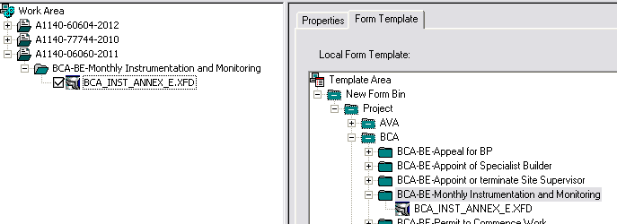

- Right click the form under work area and click “Open”

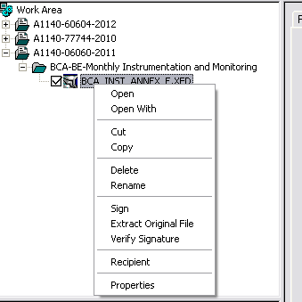

- Fill out the form then save.

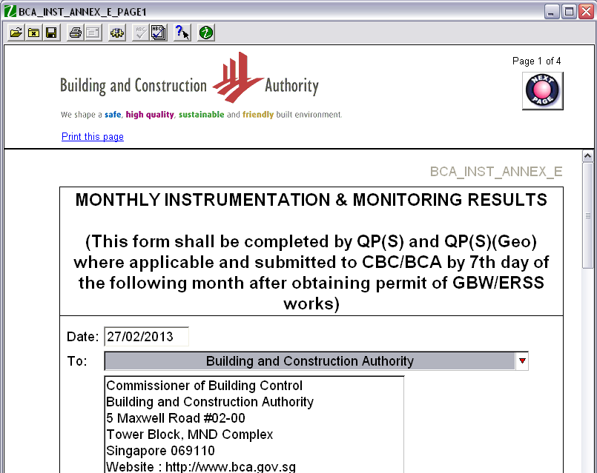

- Right click the form again under work area and select “Recipient”

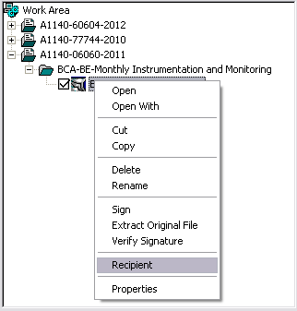

- Right click the folder (BCA-BE-Monthly Instrumentation and Monitoring) under Work Area then click submit.

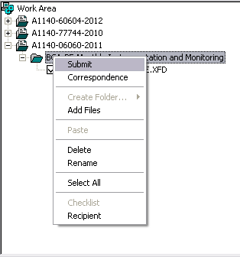

- Login to the server. A pop up screen below will appear. Click Begin.

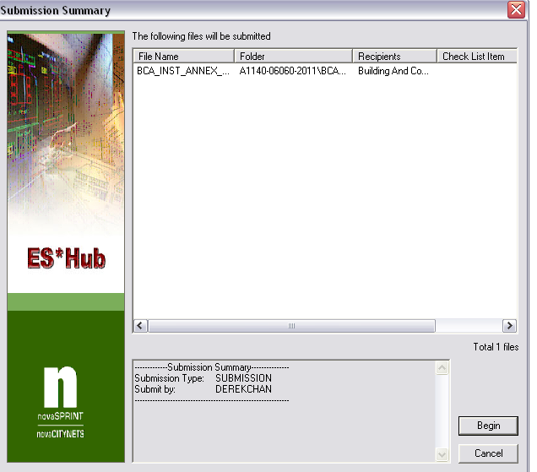

- Submission in progress screen will appear. Once submission number obtained and it is already 100% click close.

