- Assigned Solicitor’s Guide to submitting MCA Application on iFAMS

Step 1
- Once the doctor has prepared the Medical Report (MR) and affirmed it, log in to iFAMS using the Applicant’s (AP) Singpass to submit the MR:
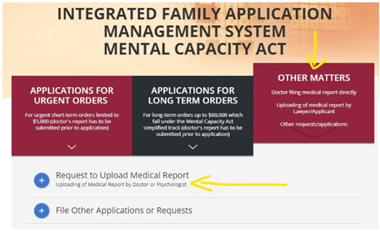
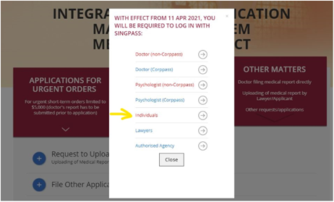
- Fill in AP and the Patient’s (P) details
- Fill in P’s medical information (see sample below)
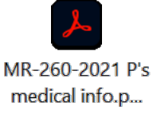
- Upload doctor’s affidavit and submit
- Wait about 1 week or less to receive an acknowledgment email that the doctor’s affidavit has been approved before going on to step 2 (see sample below).
NOTE: The uploaded MR is valid for 1 year from the date of submission of the MR on iFAMS. If an AP does not submit his/her application within this period, then the MR becomes invalid, and the AP will need to refile a fresh MR.
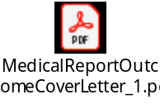

Step 2
- Fill in application details and orders sought (see sample below)
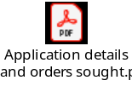
A sample of the draft orders can be found in the document attached:
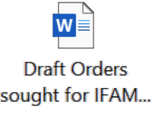
NOTE: This is not the complete list of orders which you can ask the Court to make. If you wish to include additional prayers (for e.g. reimbursement of legal costs and disbursements of the deputyship application from the P’s estate), you can include them in the free text section labelled“[INSERT ANY RELEVANT INFORMATION HERE]” on iFAMS.

- Fill in relevant persons details (see sample below)

- Upload supporting documents (to combine all supporting documents into 1 file) and separately, NRICs of AP and P (see sample below)

- Declaration by AP and review application (see sample declaration below)

- Download a copy of the application (see sample below)
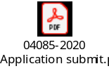
- Submit application
  - Save a copy of the acknowledgment page showing the application number as the application number is required to make payment
  - Relevant persons to submit declaration/consent (if any) – Relevant persons have to provide a valid email address and Singpass account as the FJC will email them a link to log in using their Singpass and check the box to confirm that they consent to the application
  - AP to make payment ($12 for doctor’s affidavit, $40 for application. Total: $52). AP must make payment before application can be submitted to FJC.

- Once 1-6 is done, wait for the Judge’s directions and judgment (about 3 weeks from the time AP makes payment for the application) – if the judge has any directions / clarifications, FJC will contact you. However, if after 4 weeks there is no news from them, you can contact FJC for an update.

APs should be encouraged to use the iFAMS on their own if possible. If they are able to do this, you can return the assignment to LAB.
You can contact the Bureau to obtain a list of the Bureau’s volunteer doctors who may be able to assist the AP to upload the MR by themselves.
The filing fee of $40 can be waived in the event a Grant of Aid (GA) has been issued to AP, and is filed. You should contact LAB for the filing of the GA.

