Updated in April 2025
NAC-AEP E-Services Portal

User Guide for Applications (2026 Cycle)
Contents

Before You Start  Submission of New NAC-AEP Application | 4  5
Application Process  1. Programme Description ……………………………………………………………………………….…………………  2. Lesson Plan  3. Cost and Technical Requirements …………………………………………………………………………………..  4. Contact …………………………………………………………………………………………………………………………..  5. Summary View ..……………………………………………………………………………………………………………..  6. Next Steps ..……………………………………………………………………………………………………………………. | 8  14  19  21  22  25



About NAC-AEP 2026 Cycle

Applications are now open for new programmes for the National Arts Council Arts Education Programme (NAC-AEP) 2026 cycle. Individual artists and Representatives from arts groups/ organisations can submit applications for their arts education programmes to be part of NAC-AEP. This document will guide you in submitting an application.

For more information on NAC-AEP and open call for applications, visit For Artists/Arts Groups | National Arts Council (nac.gov.sg).

Key Dates
April to May 2025 | 2026 Cycle Application Window  Applications open online on 21 April 2025 and close at 23:59 (SGT) on 23 May 2025 based on system clock. Late applications will not be accepted.
June to August 2025 | Application Assessment Period  NAC will review the applications and may contact you if clarifications are needed.
September to November 2025 | Notification of Application Results and Registration of Programme Instructors  Application results will be released between September to October 2025.  Providers are responsible for engaging qualified arts instructors who meet the instructor’s credentials (outlined in the assessment criteria) required to deliver the approved programme to schools. Providers with approved programmes will need to inform the instructors they are working with to register on the NAC-AEP portal and submit their CVs for NAC’s assessment*.  *Providers can subsequently tag the relevant approved instructors to their approved programmes. Approved programmes will not be published on the directory if instructor tagging is not completed.
December 2025 | Publication of 2026-2028 Directory  Programmes to be published on the NAC-AEP directory.

Before You Start

Register or login to your account
To submit applications for NAC-AEP in the 2026 cycle as part of a Company/Collective or as an Individual, you will need an account. For assistance on creating an account, refer to New User Registration Guide.

You do not need to create an account if you are already a/an:
- NAC-AEP registered Company/Collective or Individual
- Instructor teaching/conducting NAC-AEP

*Note* Not sure if you have an account? Check by logging into the NAC-AEP E-Services portal with your Singpass/Corppass.
*Tip* For existing users, if you are unable to login, or do not see user/representative accounts, do not create a new account. Instead, log into the Corppass Administrator site and ensure that your account is linked correctly to “NAC E-SERVICES & CRM SYSTEM” under Account Permissions.

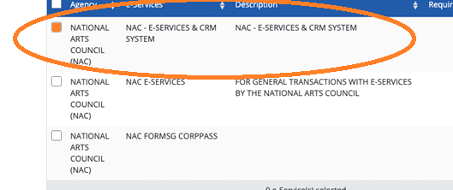
Fig. 3 Corppass ‘NAC – E-services & CRM System’

Update your individual or company particulars
The portal now allows for upload of personal profile picture for all users. For Company and Collective reps, we strongly encourage you to upload your organisation logo and a description of what your organisation does in terms of arts and arts education. Refer to page 13-15 of the User Guide for Account Registration and Maintenance or more information.

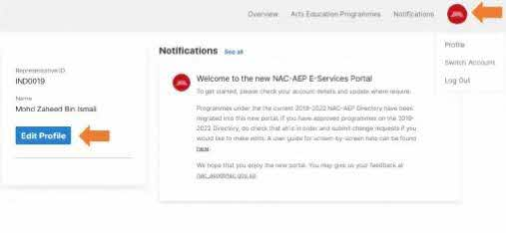
Fig. 4 Updating Individual or Company particulars

Reading up in advance

In addition to the NAC Arts Education Framework, we strongly recommend reading on the Application Process outlined in this guide.

Applicants should:

i. Download and familiarise with the Assessment Criteria and Terms and Conditions as well as the Programme Design Guide for mainstream, special education and preschool programmes before submitting an online application. Applicants must read and accepted all the Terms and Conditions of NAC-AEP before submitting an application.
ii. You are encouraged to prepare for the application in advance by referring to the Sample Application Form for the information you will be required to provide.
- The application would require you to provide mandatory details of the proposed NAC-AEP in four sections:
- Programme Description including title, synopsis, student profile
- Lesson Plan(s) and goals, up to 8 sessions
- Programme Cost(s)
- Contact information for schools
- The application process will take about 90 minutes.
- Save your draft application regularly to avoid potential loss of data during the application process. You can also opt to save and continue working on your draft application later by clicking the ‘Save and Continue Later’ button.
- Review your application before submission by clicking the ‘Submit’ button. Draft application(s) will not be considered as submitted and will not be assessed.
- To support schools in better programme discovery, you may also wish to include optional details including Images links (1 cover image and 3 carousel images) and customisable add-ons. Alternatively, you can do so after your programme has been approved.
- You will be required to upload a list of up to 5 potential instructors that you would be engaging if the application is approved, using this template. In the same document, you would also need to provide your school engagement plans. This information is to be submitted for assessment.

Submission of New NAC-AEP Application
- Navigate to NAC-AEP Directory website and click on the ‘Login’ menu at the top right corner.
- Click on any of the appropriate options under ‘Existing Users’, e.g. ‘Company Representatives/ Collective Representatives/ Individual Programme Providers’.
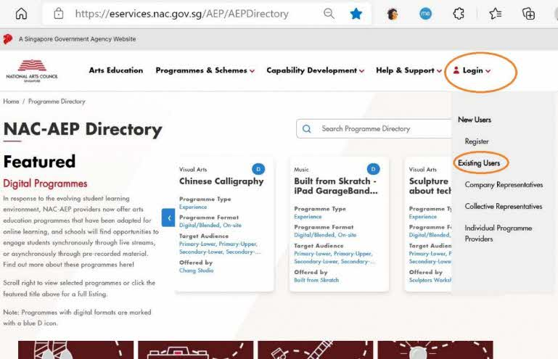
Fig. 5 Login Page

- Login with Singpass
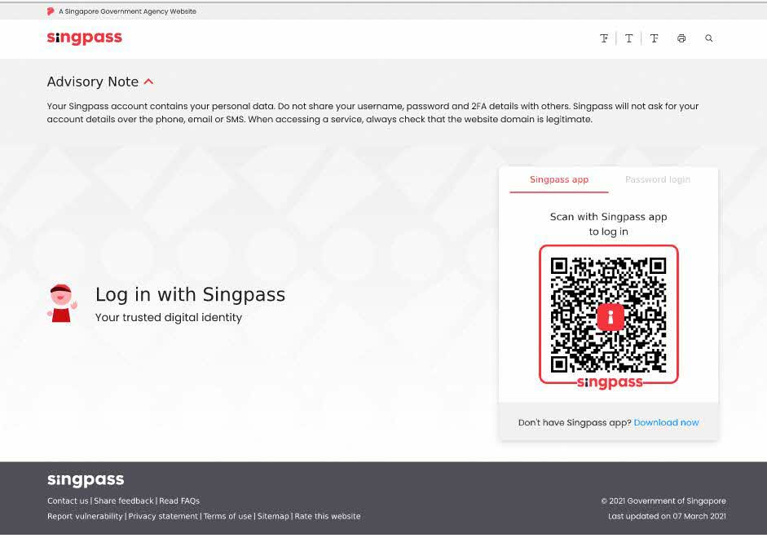
Fig. 6 Log in with Singpass Page
- After a successful log in, you will be brought to your Provider Profile page.
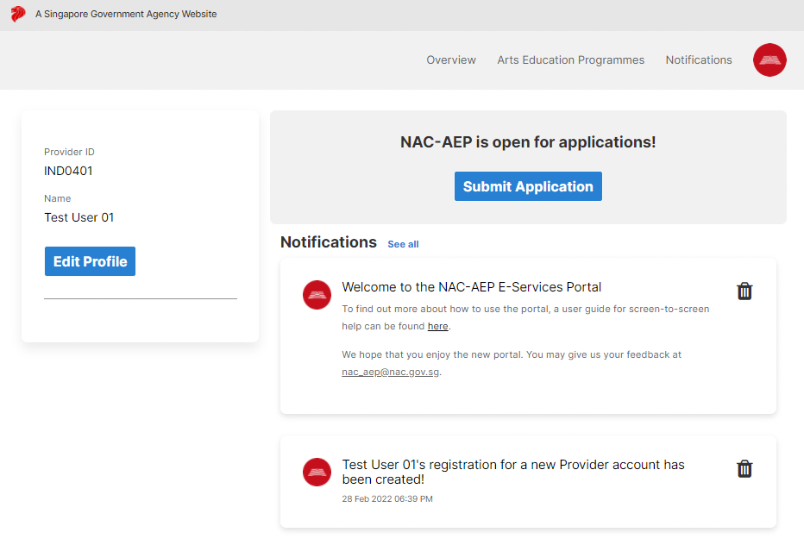
Fig. 7 Provider Profile Landing Page
- Click ‘Submit Application’.
- You will be redirected to ‘Important notes’ page before accessing the application form. Read the information as well as the terms and conditions, and click on the acknowledgement before submitting any application.
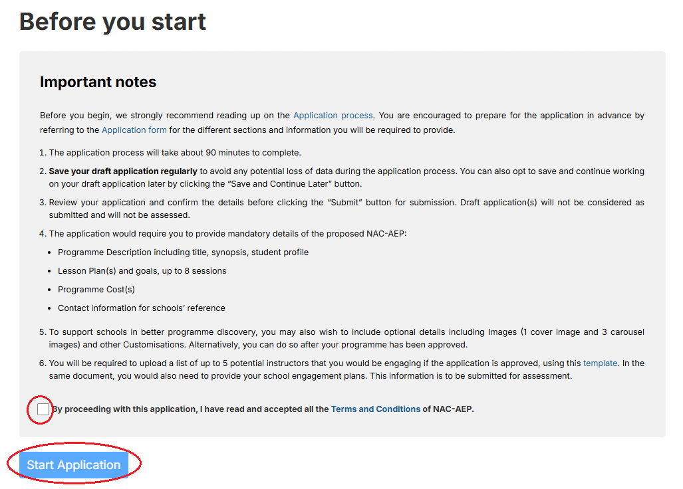
Fig. 8 Introductory Page
- You will not be allowed to submit any applications after the application submission deadline.
- When ready, click on the ‘Start Application’ button. You will then be brought to the first of four sections – Programme Description.
NOTE: All applications must be submitted through the NAC-AEP E-Services Portal by 23:59 (SGT) on 23 May 2025. Draft applications saved within the system that were not submitted will not be considered.
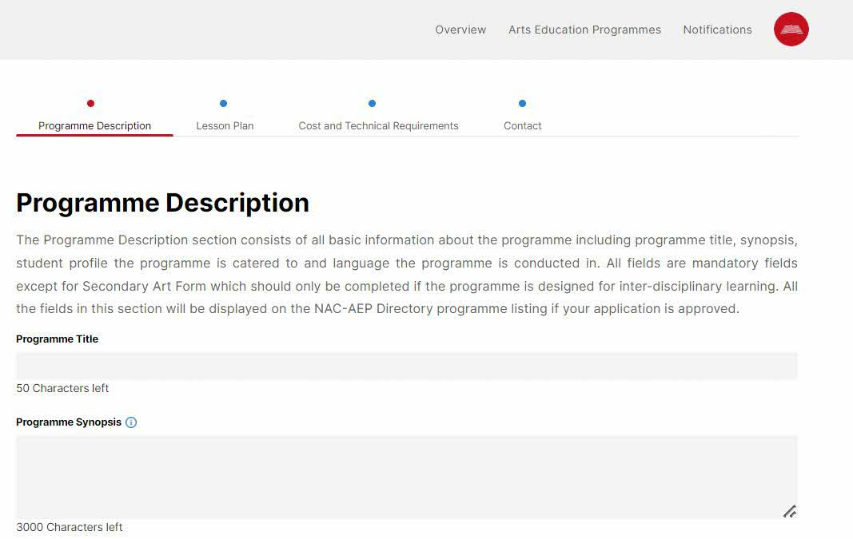
Fig. 9 Programme Description Page

Application Process

1. Programme Description
The Programme Description section consists of basic information about the programme including Programme Title, Programme Synopsis, Student Profile the programme is catered to and Language the programme is conducted in. All fields are mandatory fields except for Secondary Art Form which should only be completed if the programme is designed for inter-disciplinary learning. All the fields in this section will be displayed on NAC-AEP Directory programme listing if your application is approved.
*Tip* For more information on each field, mouse over the blue information icon and tooltips will be displayed.

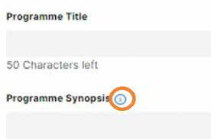
Fig.10 Blue Information icon

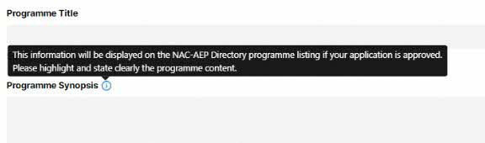
Fig. 11 Tooltips

a. Programme Title
Enter the name/title of you programme in the box/field. Note: There is a 50-character limit, do not include cycle year e.g. 2023-2025 in your title. There are now filters for you to sort your programmes by cycle so this is no longer necessary.

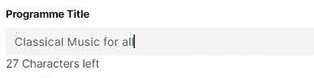
Fig. 12 Programme Title

b. Programme Synopsis
Enter a short summary of your programme (3,000-character limit). This information will be displayed on the NAC-AEP Directory programme listing if your application is approved. Highlight and state clearly the programme content. You may give more detail in Part 2 Lesson plan.
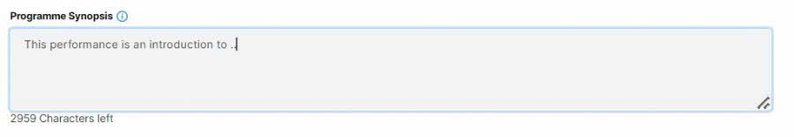
Fig. 13 Programme Synopsis

c. Primary Art Form
Select one main art form of your programme by clicking on the dropdown arrow. Your programme will be listed under the selected Primary Art Form category on the Directory.

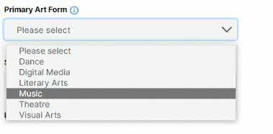
Fig. 14 Primary Art Form

d. Sub-Genre
Once an Art Form is selected, a list of sub-genres available will be displayed. Select a genre (up to 3) that best describes your programme. Your programme will be listed under the selected sub-genre filters on the Directory.

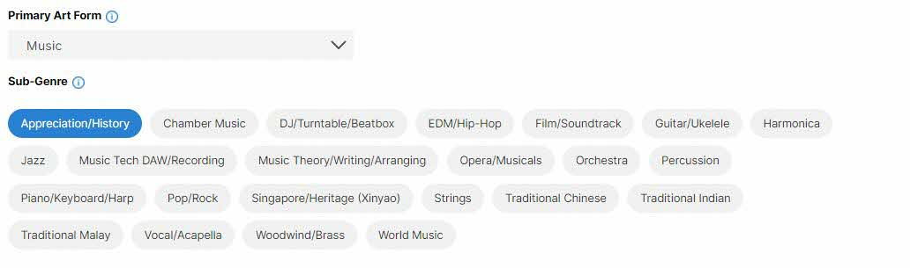
Fig. 15 Sub-Genre

e. Secondary Art Form and sub-genre
Add a secondary art form with the relevant sub-genre(s) only if the programme is designed for inter-disciplinary learning.
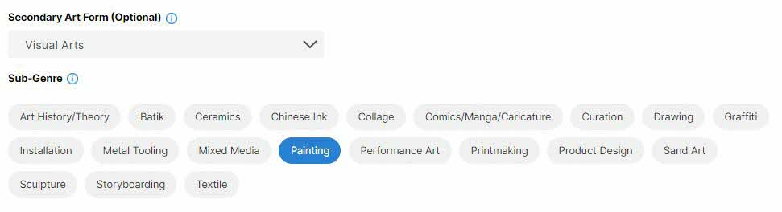
Fig. 16 Secondary Art Form and Sub-Genre

f. Language
Select language(s) used in the teaching and/or presentation of your programme. If Others is chosen, a new field box Other Language will appear for you to indicate the specific language the programme is conducted in.
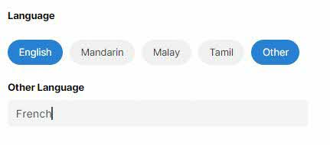
Fig. 17 Language Options

g. Student Profile(s)
Select the student profile(s) that your programmes cater to. Programmes will be assessed according to how they are designed intentionally for the student profile. If selecting a range, ensure that strategies for differentiation are elaborated upon in the Lesson Plan.

NOTE: Programmes targeted at pre-schools must be submitted separately from mainstream school programmes.

h. Recommended Class Sizes
Fill in the indicative Minimum and maximum limits to the class/cohort sizes that the programme was intended for.
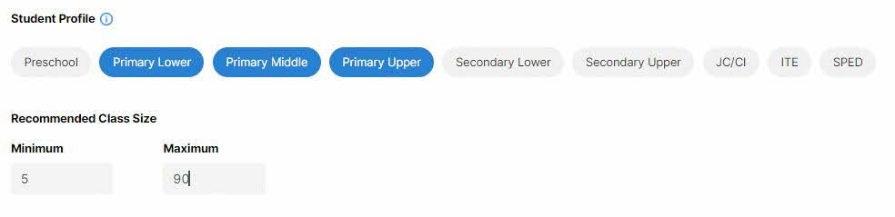
Fig. 18 Student Profile and Recommended Class Size

i. Programme Type
Select the appropriate Programme Type by clicking on the dropdown arrow. If performance is selected, upload a copy of your script/repertoire in word or pdf format using the “+” button.
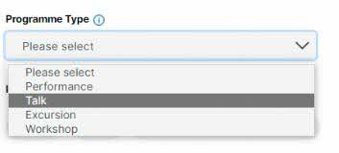
Fig.19 Programme Type
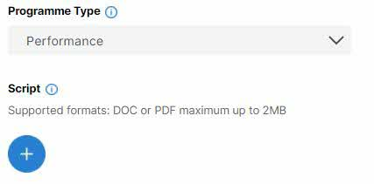
Fig.20 Programme Type – Upload Script Button

Once upload is successful, the filename will be displayed. To delete, click on the red “X” beside the filename.

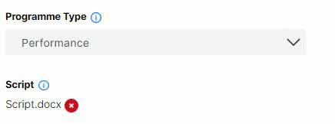
Fig. 21 Successful Upload of Script

If Excursion is selected, a new field Venue will appear. Fill in the Venue.
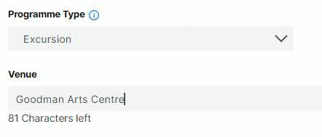
Fig. 22 Programme Type – Excursion and Venue

j. Programme Format(s)
Select the available formats (online/digital/blended) that is available for your programme. If you select more than one, elaborate on this in the Lesson Plan Section, the ways in which the programme will be delivered. NAC will assess the different formats proposed accordingly.

k. No. of Instructors/Performers Required
Indicate the minimum number of instructors or performers required to conduct this programme.
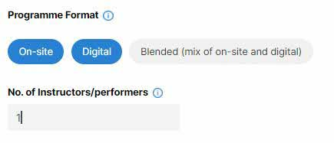
Fig. 23 Programme Format and No. of Instructors/Performers
l. Cover Image
This cover image will be displayed as a banner on the NAC-AEP Directory programme listing page, as well as in the search pages (Figs. 21 and 22).

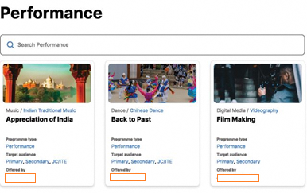
Fig. 24 Sample cover image on search listing
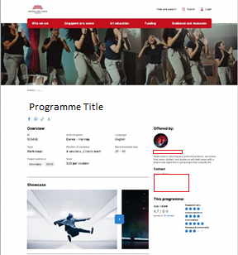
Fig. 25 Sample Cover image (Banner) and Carousel Images/Videos

This will be a mandatory field after your programme is approved. To upload, click on the “+” button.

Optimal dimensions 730*480
Supported formats: PNG or JPG maximum up to 2MB

m. Carousel Images
These images (up to 3) will be displayed on your programme listing page and will be included after your programme is approved. To upload, click on the “+” button. If upload is successful, thumbnail images will be displayed.

Optimal dimensions 1400*370
Supported formats: PNG or JPG maximum up to 2MB

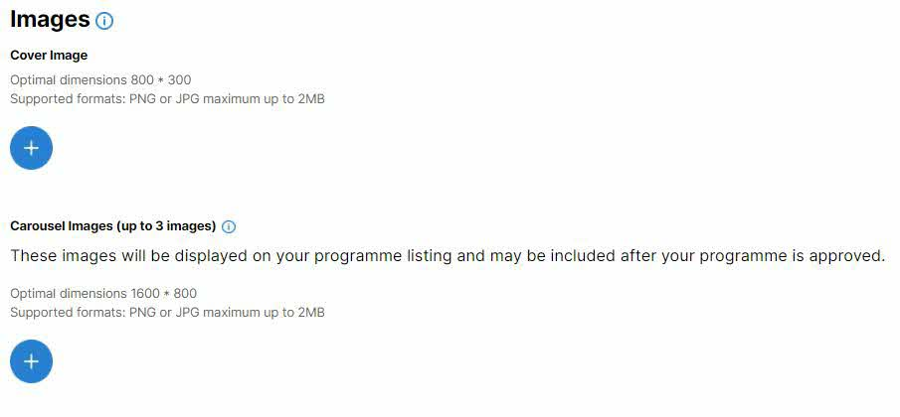
Fig. 26 Upload of Cover and Carousel Images

If upload is successful, a thumbnail image will be displayed.

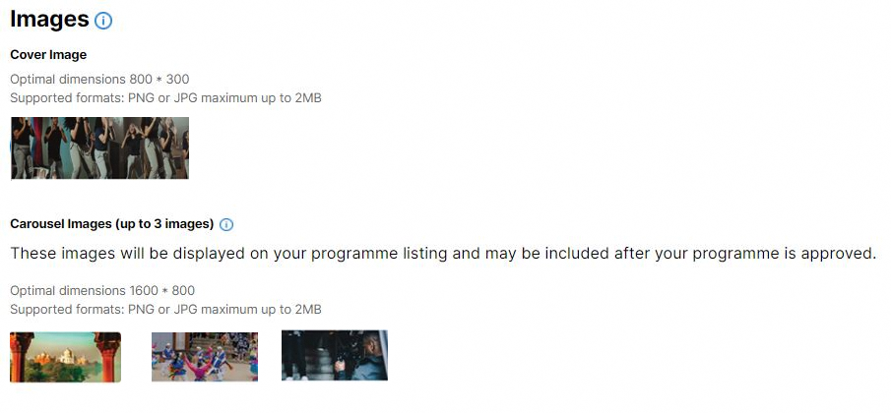
Fig. 27 Successful upload of images

*Tip* If your image looks stretched, Resize to the optimal dimensions provided. This affects how your image will be displayed on the NAC-AEP directory.

*Important* If your image features students or children, you are required to seek permission and receive consent for the use for the photos from the relevant parties.

Complete this section of the form and remember to save before going on to the next section by clicking on the “Save”, and “Next >” buttons.

Fig. 28 “Save” and “Next >” Buttons
2. Lesson Plan
The Lesson Plan section requires you to demonstrate how the programme is designed to achieve the intended learning objectives that are guided by one or more of the Focus Areas (and one of the 5 Points of Emphasis if applicable) in the NAC Arts Education framework. This section also requires you to show how the programme adopts various active learning strategies that would cater to the student profile(s) identified. If you have selected more than one student profile, describe how the lessons would be differentiated. Lesson plan breakdown and supporting documents provided for assessment will not be publicly listed or distributed.
The section consists of overall Lesson Goals and Lesson Plan Breakdown based on sessions, and customisation options that you can offer to schools.
In addition, NAC will also assess applicants’ track record and experience in delivering arts education programmes. New programme providers will be required to provide additional information to illustrate their capability in providing quality arts education experiences for students.
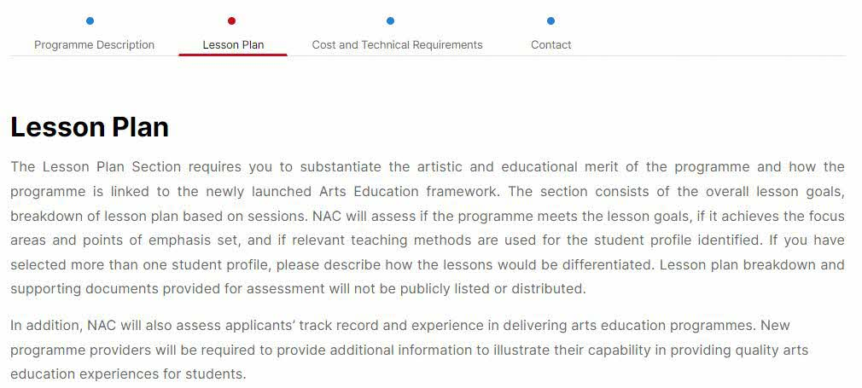
Fig. 29 Lesson Plan Page

a. Focus Areas
Choose the Focus Area(s) that features prominently in your programme. More information on the Arts Education Framework can be found on the NAC-AEP Website.

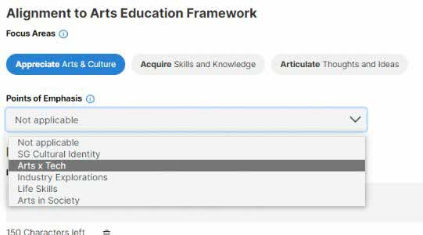
Fig. 30 Selection of Focus Areas

b. Points of Emphasis (PoE)
Programmes will be further assessed for their relevance if a Point of Emphasis is selected. Select only one PoE.

Fig. 31 Points of Emphasis

c. Lesson Goals
Fill in up to three Lesson Goals. These are the specific programme objectives for the whole programme that provide details on the selected Focus Area(s) and Point of Emphasis (if any). To add more goals, click the “+ Add Lesson Goal” and a new row will appear. To remove, click on the ‘Trash’ icon. Do indicate how your learning objectives map to the Focus Area(s) and/or Points of Emphasis if selected.

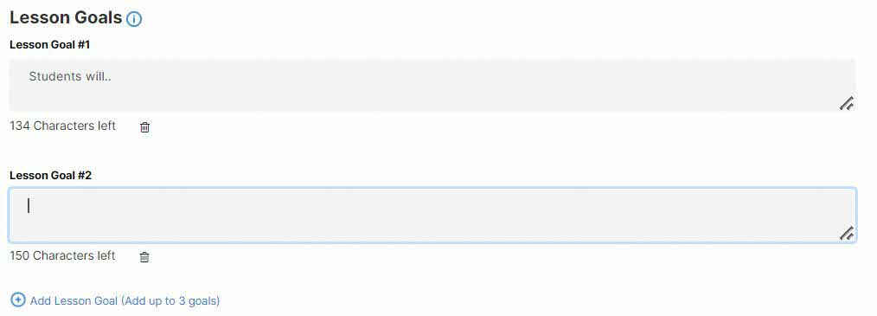
Fig. 32 Lesson Goals

d. Lesson Plan Breakdown
(For Internal Assessment, not shared or distributed for other purpose)
Lesson plans breakdown is a planned outline of the different sessions and activities that make up the complete progamme. Each programme can have one or more sessions (up to 8 Sessions) and each session can have any number of activities and of any duration (minimum of at least one activity).

Start with Session 1 and click on “+ Add Row” to add different activities and provide details for different components/learning activities of the session.
To delete, click on the “X”.

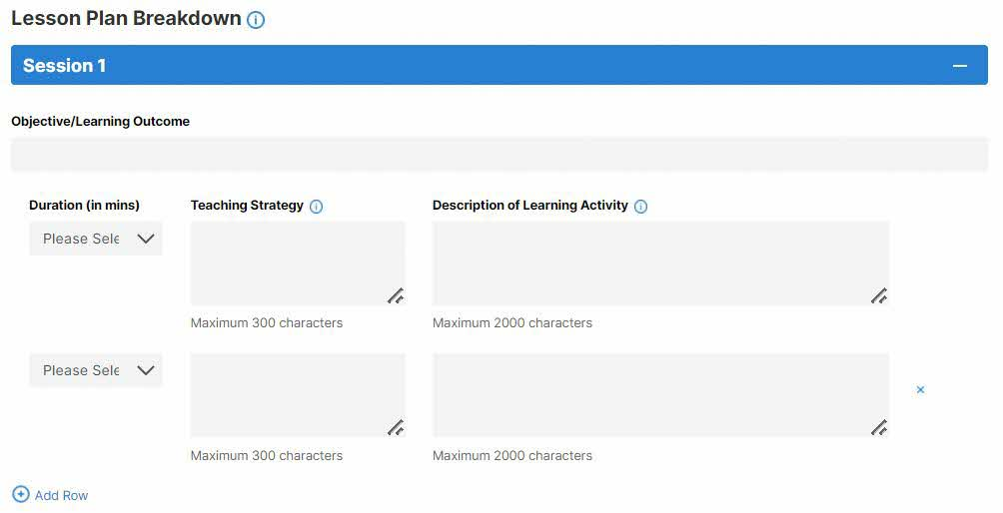
Fig. 33 Adding Rows to Session

You may add up to eight sessions per programme. Use the “+ Add Session” button to add additional sessions. To delete, click on the “Delete Session” button.

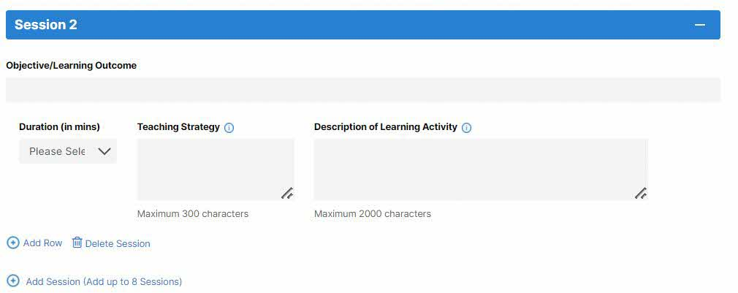
Fig. 34 Adding of Sessions
e. Sessions
For each session, complete the following:

i. Objective/Learning Outcome
Fill in the lesson objective of the specific session

ii. Duration – Enter the duration of each learning activity (in 5 min increments).

iii. Teaching Strategy – Provide details of the teaching strategy used to engage students in learning. (e.g. think-pair-share to allow students to think independently before sharing with a peer; working in small groups to brainstorm ideas; pose open-ended question to encourage thinking about the topic.) Teaching Strategy could also include art form specific strategies or rationale/purpose of learning activities. The plan should include differentiated strategies for different student profiles.

iv. Description of Learning Activity – Fill in detailed descriptions for all learning activities. Give sufficient detail of the activities conducted in the programme and include differentiated activities for different student profiles where relevant. Your proposal will be assessed for suitability for each student profile indicated (i.e. Primary vs Secondary etc).
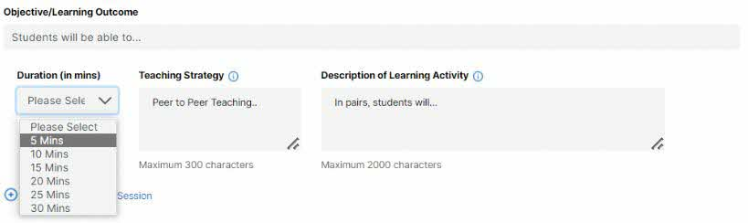
Fig.35 Objective/Learning Outcome, Duration, Teaching Strategy and Description of Learning Activity

f. Duration and Number of Sessions
The following are auto calculated upon completion of “Duration” and “Number of Sessions” indicated:

i. No. of Sessions
ii. Total Duration

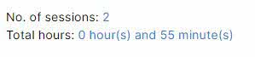
Fig. 36 Auto-calculation of session and duration

g. Customisation Options (optional)
Programme providers can provide schools with the option to customise certain components of the programmes e.g. programme duration (including number of sessions), class size and add-ons to cater to different interests and learning needs. Programme cost can vary based on the customisation required by schools and agreed by providers. Please put the price of your customisation component into the description of learning activity.

You may choose to offer add-ons to your programme. Additional materials may be requested for assessment purposes. If you would like to offer further add-ons, elaborate in the appropriate fields – “Additional Component/resources”, “Teaching Strategy” and Description of Learning Activity”. To add more customisation options, click “+ Add Row”. To delete, click on the “X” button.

i. Only Additional Components/Resources will be publicly displayed on the programme detail page. Click on the dropdown arrow to reveal possible customisation options. For Others, specify the additional customisation.

- Additional Component – Performance
- Additional Component – Excursion
- Additional Component – Talk
- Additional Component – Workshop
- Additional Resource – Learning materials
- Additional Resource – Videos/links to online content
- Additional Resource – Teachers guides/assessment tools
- Others

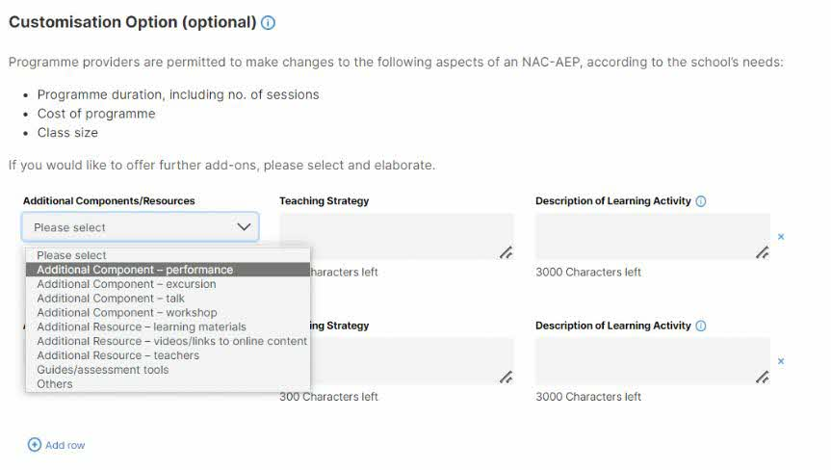
Fig. 37 Customisation Options

*Important* Programme costs (artists fees, materials necessary to conduct the programme) are claimable but not the purchase of equipment or assets, transportation of students or video productions/recordings for showcases).

h. Track Record

*Important* Indicate if the programme was previously approved, or if you currently have approved programmes in the 2023-2025 NAC-AEP cycle.

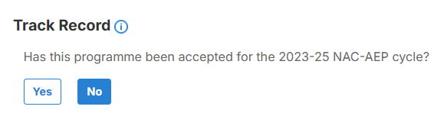Fig. 38 Track Record (Yes)please

You will be required to upload a list of up to 5 potential instructors that you would be engaging if the application is approved, in this template. In the same document, you would also need to provide your school engagement plans. This information is to be submitted for assessment. To upload, click the “+” button. Acknowledge the declaration by clicking on the empty box, a tick will appear.

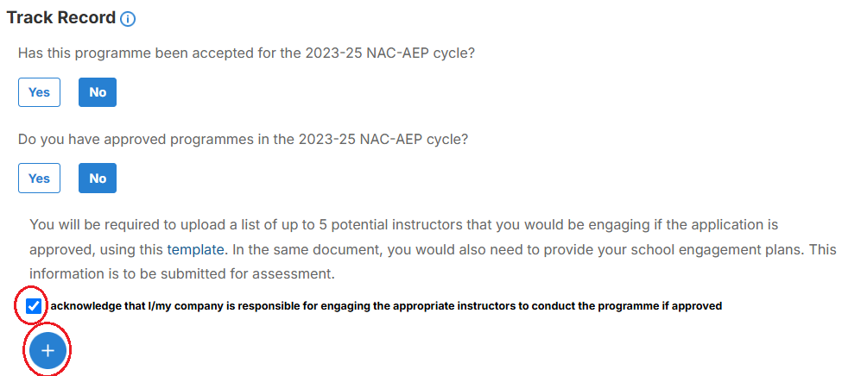
Fig.39 Track Record (No) with Additional Question, Declaration and File Upload Button

If successful, the name of the file will be displayed. To delete, click the red “X” button.

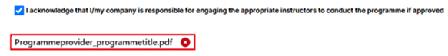

Fig. 40 Successful File Upload

Complete this section of the form and remember to save before going on to the next section by clicking on the ‘Save’ and ‘Next >’ button. Alternatively, you may click on ‘< Previous’ to change information in Part 1.

3. Cost and Technical Requirements

The Cost and Technical requirements section is to provide logistics information about the programme for teachers. Programme costs indicated are for reference and can be adjusted based on customisation upon request from schools. Technical requirements are particularly important for teachers to assess if they have the necessary equipment and facilities to support your programme so do provide clear information. All the fields in this section will be displayed on the NAC-AEP Directory programme listing if your application is approved.

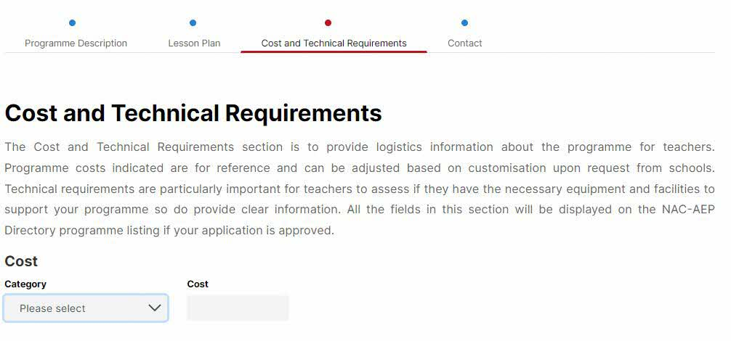
Fig. 41 Cost and Technical Requirements Page

a. Cost
Fill in the amount in SGD and corresponding values by clicking on the dropdown arrow (per session, hour, student). To add different costs, click on “Add another cost”. You may include up to three different costs.

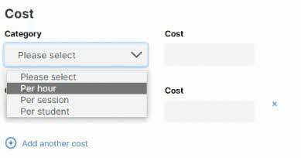
Fig. 42 Addition of Different Costs

b. Technical Requirements
Where relevant, select the any of the following option(s) that schools would need to provide to conduct the programme. A tick will appear when selected.

c. Other Requirements
You can indicate any other technical requirements required for the different programme format(s) such as description of room sizes, flooring or stable internet connection, or if students would need personal devices, etc in the free text box. If you are offering multiple programme formats or digital/hybrid version(s) of the programme, share more information about how schools can support you in the delivery of the programme.

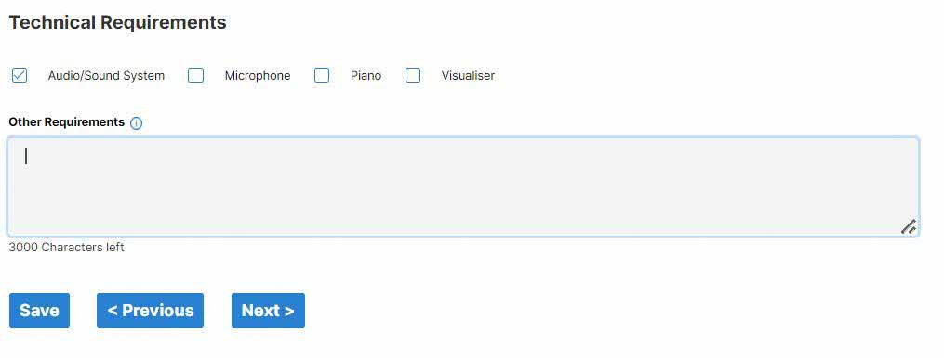
Fig. 43 Technical Requirements

Complete this section of the form and remember to save before going on to the next section by clicking on the “Save” and “Next >” button. Alternatively, you may click on “< Previous” to change information in Part 2.

4. Contact

The Contact Section consists of contact information for schools to reach you. Do ensure that your profile and contact information is up to date. All the fields in this section as well as the company logo/profile picture and description you upload as part of your user account profile will be displayed on the NAC-AEP Directory programme listing if your application is approved. To add additional contact personnel, click on ‘Add another contact person’.

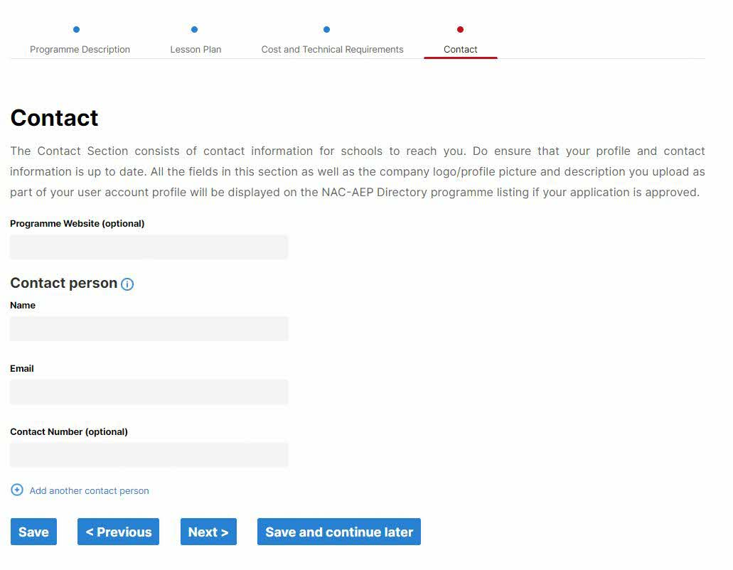
Fig. 44 Contact page

Complete this section of the form and remember to save before going on to the next section by clicking on the ‘Save’ and ‘Next >’ button. You will be brought to the Summary View Page. You may click on ‘< Previous’ to change information in Part 3.

*Tip* Alternatively, if you would like to come back to the application, click on “Save and Continue Later”. Your programme will also appear as a draft under the 2026 cycle on your provider profile landing page.
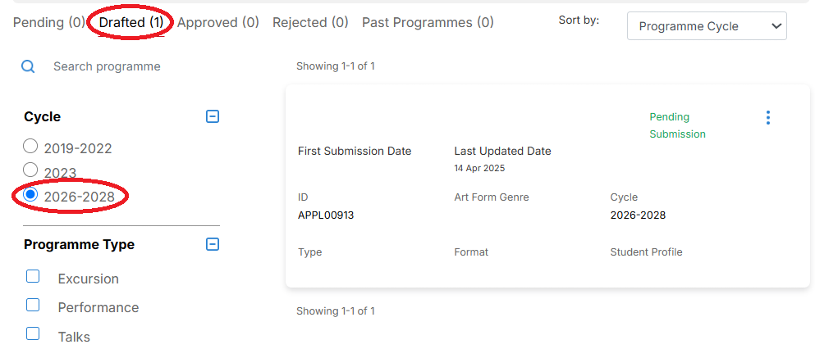
Fig. 45 Provider Profile Landing Page

6. Summary View

In this page, you will be able to make final edits to you programme application. Click on the ‘+’ buttons to expand the various sections. Click on ‘Edit’ to make changes to your application. To close a section, click on ‘-‘.
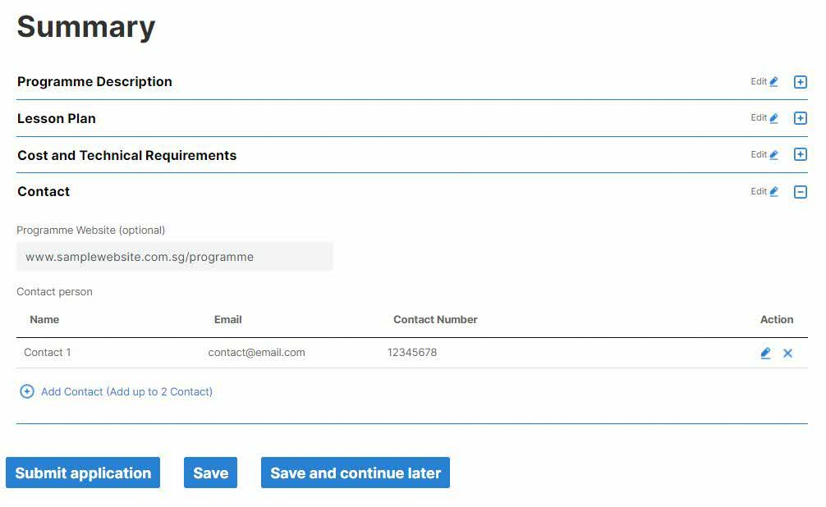
Fig. 46 Summary View.

*Tip* You will not be able to submit your application if any of the mandatory fields are blank. You will see this alert.

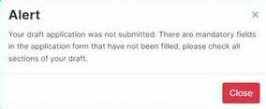
Fig. 47 Alert for Incomplete Applications

If so, check through the sections by expanding them with the “+” icons. Missing mandatory fields will be highlighted in red.

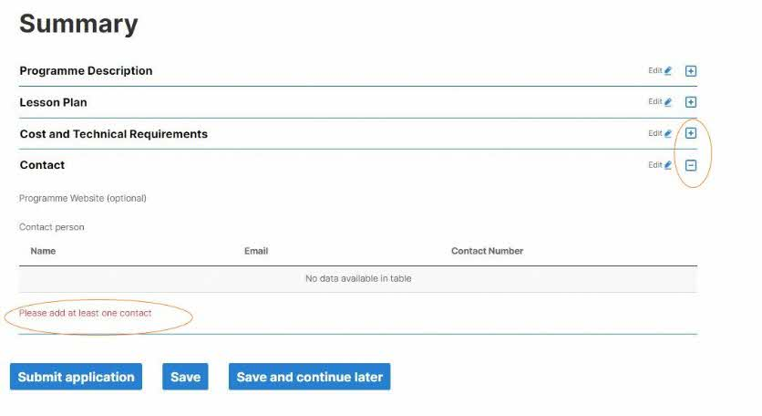
Fig. 48 Blank fields

If you are ready to submit, click the ‘Submit application’ button. Once submitted, you will be brought to the Acknowledgment Page. All applications will be issued with an Application ID and Date of Submission.

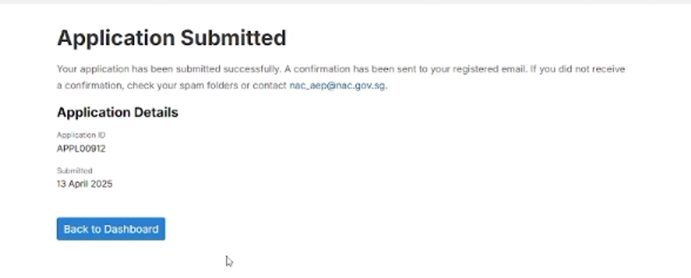
Fig. 49 Acknowledgement Page

Your programme should appear as a card in the Pending section under the 2026-2028 cycle.

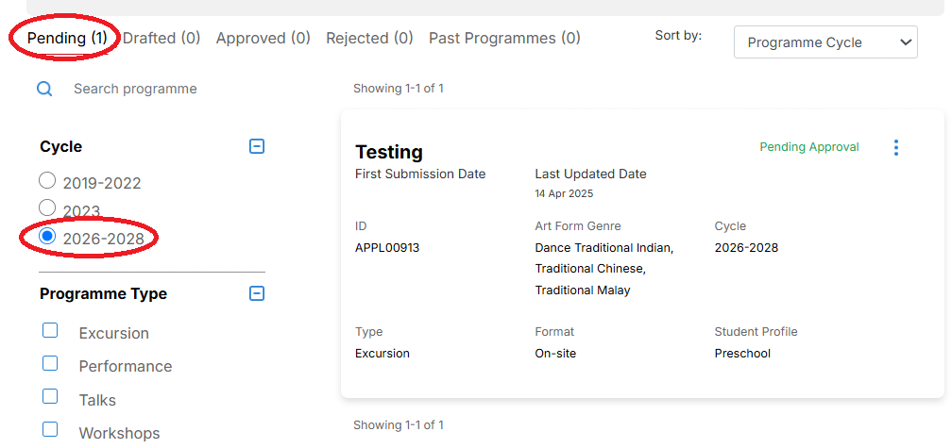
Fig. 50 Pending Programmes on Provider Profile Page.

*Troubleshooting* If you are unable to submit an application, take a screenshot of the error page (if any) and complete your application using the Sample Application Form and/or Potential Instructor List. Email both the forms and technical error page to nac_aep@nac.gov.sg.

6. Next Steps
The assessment period will take about three months from June to Aug 2025. During this time, NAC may contact providers directly if there are any clarifications or missing information. All applications will be rigorously reviewed by NAC and external Arts Education Representatives.

Providers that submitted applications will be notified of results between September to October 2025. Providers with approved programmes will then inform the instructors they are working with to
register on the NAC-AEP portal and submit their CVs for NAC’s assessment. Providers can subsequently tag the relevant approved instructors to their approved programmes. Approved programmes will not be published on the directory if instructor tagging is not completed. More information and guides for this process will be available at a later date.

In December 2025, all approved programmes will be published on the NAC-AEP directory.

If you encounter an issue not covered in this User Guide, contact the NAC Education Unit at nac_aep@nac.gov.sg. To help us better understand your issue, provide screenshots where relevant.



