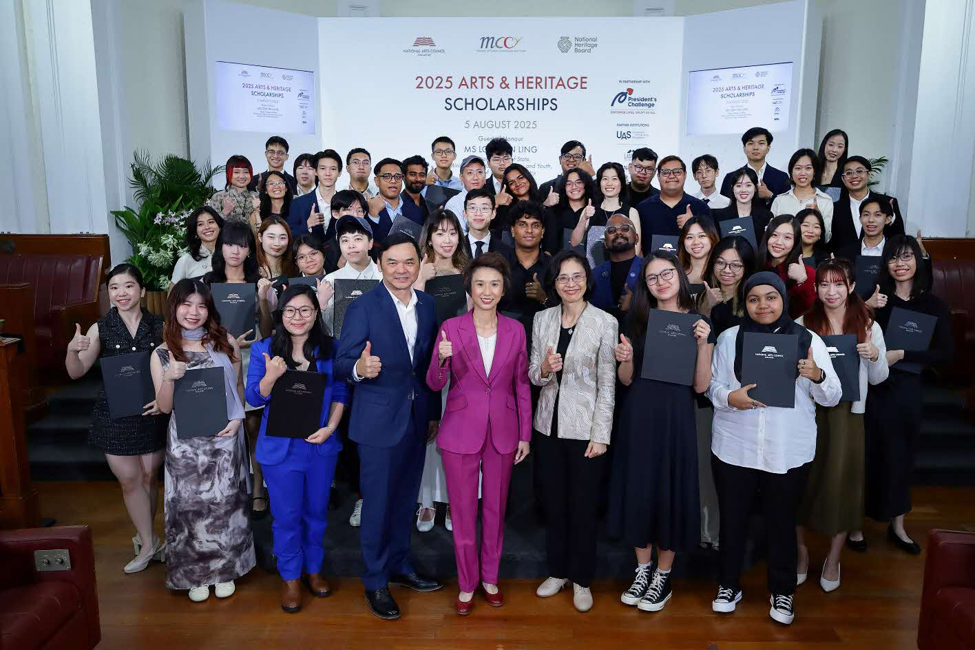

2025 Arts & Heritage Scholarship recipients with Senior Minister of State for Culture, Community and Youth, & Trade and Industry, Ms Low Yen Ling, Chief Executive Officer of National Arts Council (NAC), Mr Low Eng Teong, and Chief Executive Officer of National Heritage Board (NHB), Ms Chang Hwee Nee. Image courtesy of NAC.

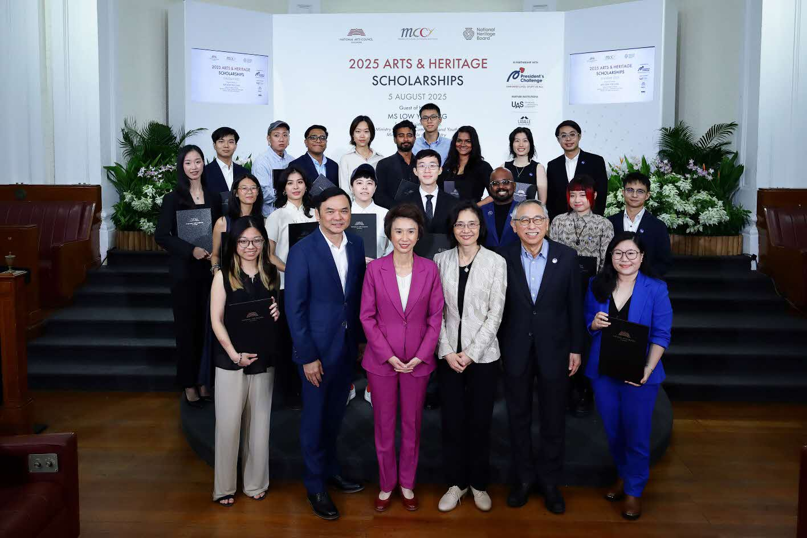

2025 NAC Arts Scholarship (Degree), NAC-UAS Scholarship, NHB Scholarship recipients with Senior Minister of State for Culture, Community and Youth, & Trade and Industry, Ms Low Yen Ling, Chief Executive Officer of National Arts Council (NAC), Mr Low Eng Teong, Chief Executive Officer of National Heritage Board (NHB), Ms Chang Hwee Nee, and Vice-Chancellor of University of the Arts Singapore (UAS), Professor Kwok Kian Woon. Image courtesy of NAC.

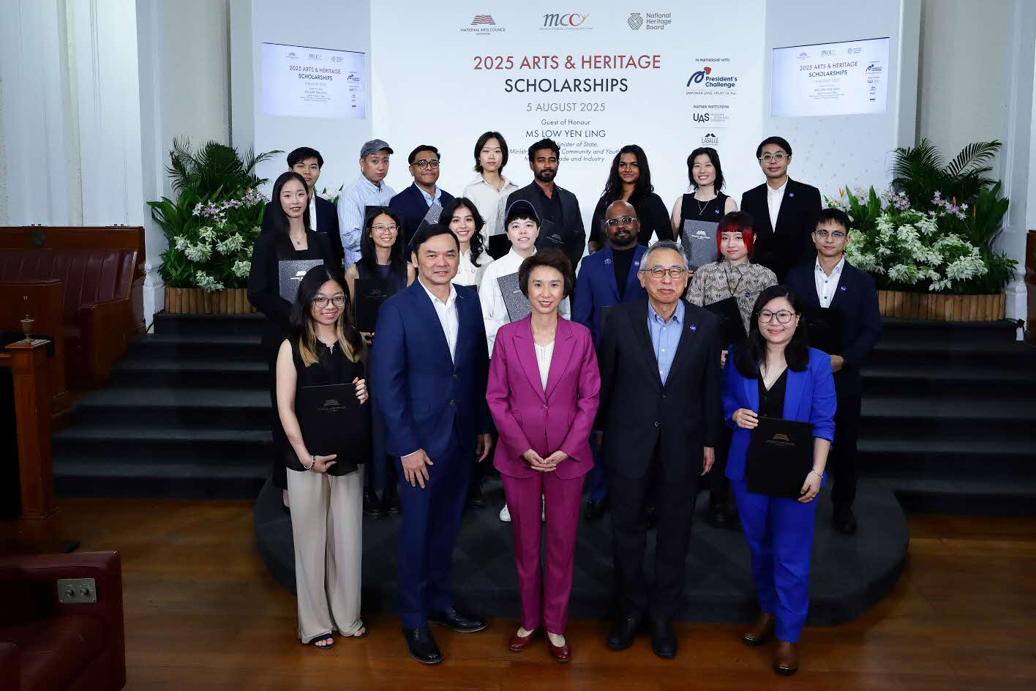

2025 NAC Arts Scholarship (Degree) and NAC-UAS Scholarship recipients with Senior Minister of State for Culture, Community and Youth, & Trade and Industry, Ms Low Yen Ling, Chief Executive Officer of National Arts Council (NAC), Mr Low Eng Teong, and Vice-Chancellor of University of the Arts Singapore (UAS), Professor Kwok Kian Woon. Image courtesy of NAC.

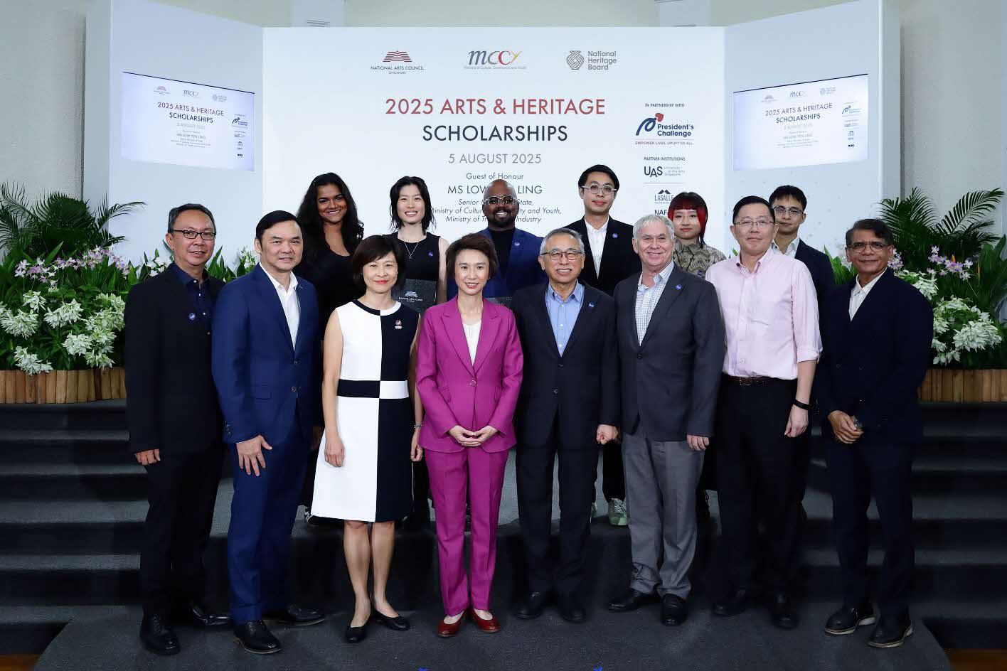

2025 NAC-UAS Scholarship recipients with Senior Minister of State for Culture, Community and Youth, & Trade and Industry, Ms Low Yen Ling, Chief Executive Officer of National Arts Council (NAC), Mr Low Eng Teong, Vice-Chancellor of University of the Arts Singapore (UAS), Professor Kwok Kian Woon, Deputy Vice-Chancellor of UAS & President of LASALLE College of the Arts, Professor Steve Dixon, Deputy Vice-Chancellor of UAS & President of Nanyang Academy of Fine Arts (NAFA) Mrs Tan-Soh Wai Lan, Chief Operating Officer of UAS, Mr Ho Chee Pong, Deputy President and Provost of LASALLE, Dr Venka Purushothaman, and Vice President (Corporate Services) of NAFA, Mr Yong Lye Yong. Image courtesy of NAC.

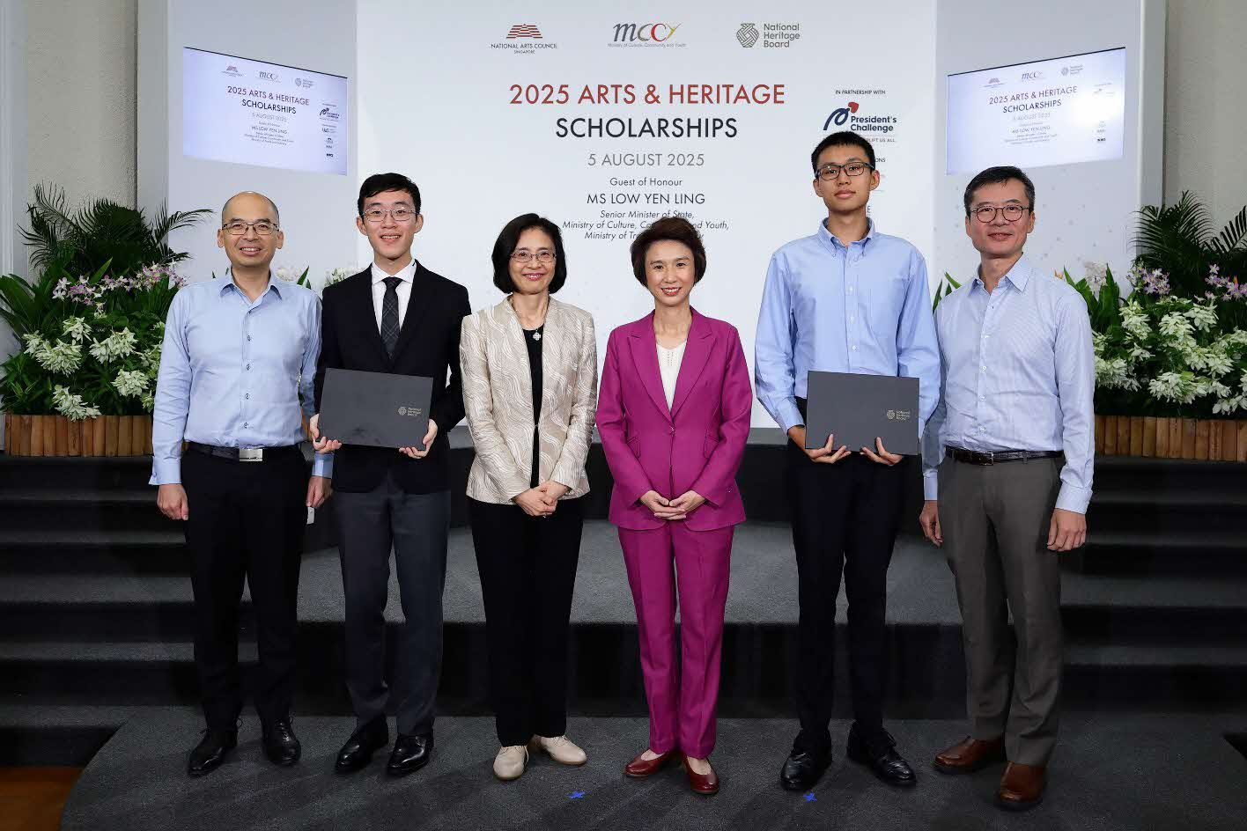

2025 NHB Scholarship recipients with Senior Minister of State for Culture, Community and Youth, & Trade and Industry, Ms Low Yen Ling, Chief Executive Officer of National Heritage Board (NHB), Ms Chang Hwee Nee, Group Director (Museums) of NHB, Mr Low Sze Wee, and Group Director (Policy & Community) of NHB, Mr Yeo Kirk Siang. Image courtesy of National Arts Council.

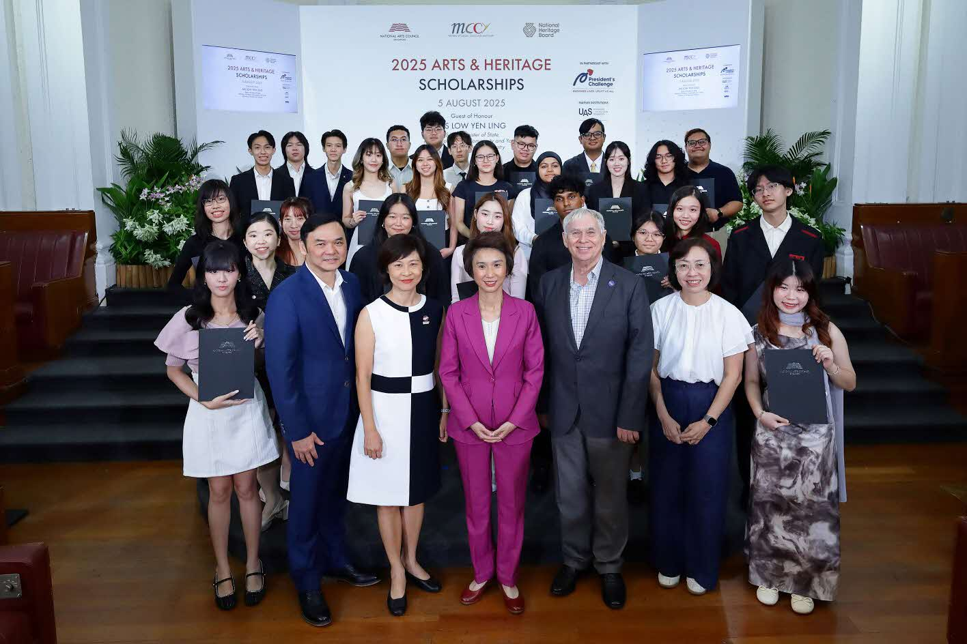

NAC Arts Scholarship (Diploma) recipients with Senior Minister of State for Culture, Community and Youth, & Trade and Industry, Ms Low Yen Ling, Chief Executive Officer of National Arts Council (NAC), Low Eng Teong, President of LASALLE College of the Arts, Professor Steve Dixon, President of Nanyang Academy of Fine Arts, Mrs Tan-Soh Wai Lan, and Principal of School of the Arts Singapore, Mrs Mary Seah. Image courtesy of the National Arts Council.

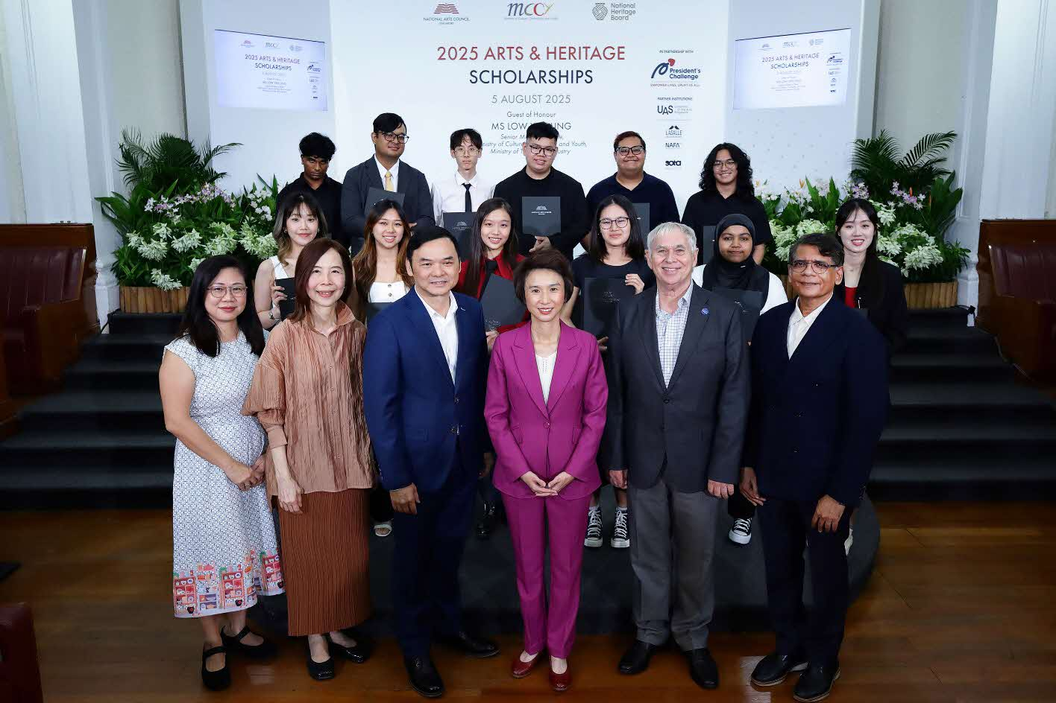

NAC Arts Scholarship (Diploma) recipients from LASALLE, with Senior Minister of State for Culture, Community and Youth, & Trade and Industry, Ms Low Yen Ling, President of LASALLE College of the Arts, Professor Steve Dixon, Deputy President and Provost of LASALLE, Dr Venka Purushothaman, Vice-President (Strategic Developments) of LASALLE, Ms Barbra Gan, and Academic Registrar & Director, Division of Student Administration of LASALLE, Ms Lee See Ee. Image courtesy of the National Arts Council.

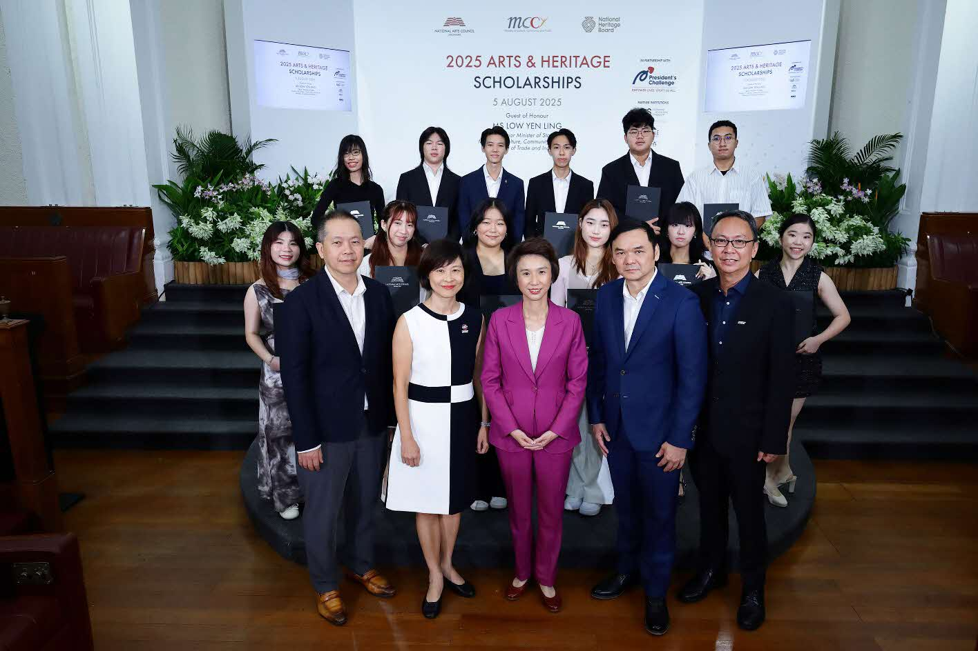

NAC Arts Scholarship (Diploma) recipients from Nanyang Academy of Fine Arts (NAFA), with Senior Minister of State for Culture, Community and Youth, & Trade and Industry, Ms Low Yen Ling, President of NAFA, Mrs Tan-Soh Wai Lan, Vice President (Corporate Services) of NAFA, Mr Yong Lye Yong, and Dean (Performing Arts) of NAFA, Dr Ernest Lim. Image courtesy of the National Arts Council.

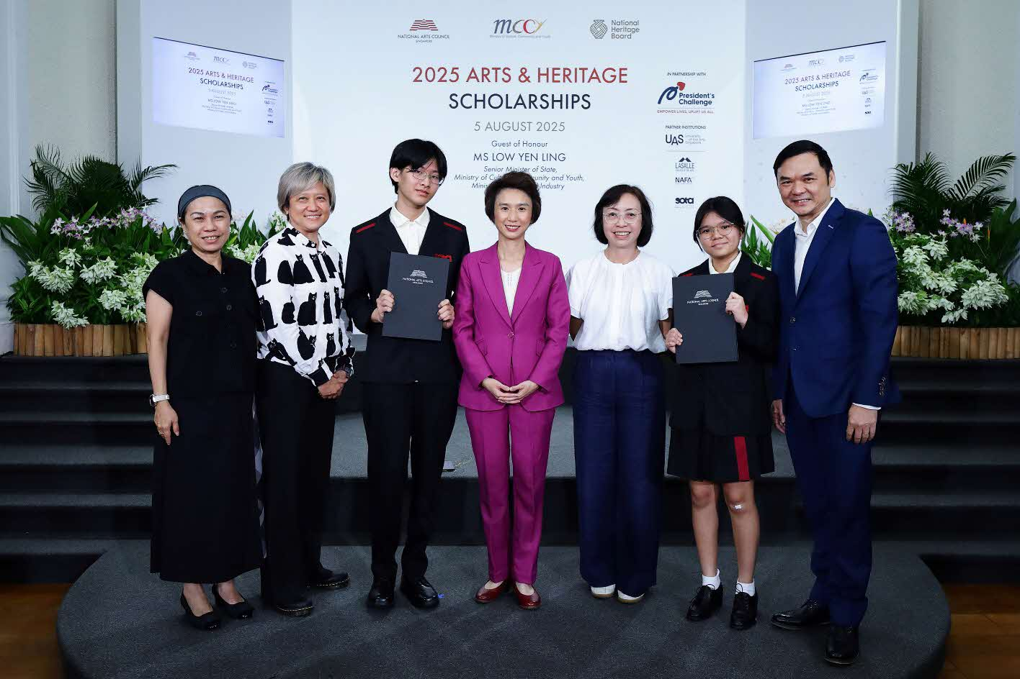

NAC Arts Scholarship (Diploma) recipients from School of the Arts Singapore (SOTA), with Senior Minister of State for Culture, Community and Youth, & Trade and Industry, Ms Low Yen Ling, Principal of SOTA, Mrs Mary Seah, Vice Principal, Academic & Affective of SOTA, Ms Pauline Ann Tan, and Director, Corporate Planning & Services of SOTA, Ms Justine Tan. Image courtesy of the National Arts Council.

