
User Guide for Account Registration and Maintenance
NAC-AEP E-Services Portal
Issued 17 December 2021
Updated 17 March 2022 and April 2025

Contents

1. Account Types 3
2. Setting up your Account: Company Representatives 7
3. Setting up your Account: Collective Representatives 9
4. Setting up your Account: Individual Users 12
5. Updating your Account: Registered Company / Collective Representatives 13
6. Updating your Account: Individual Users 16
7. Managing Multiple Accounts 18
8. Withdrawing Accounts 19

About the NAC-AEP E-Services Portal

The National Arts Council-Arts Education Programme (NAC-AEP) E-services portal is a platform for arts companies, collectives, individual programme providers and instructors to submit applications, manage their programme and instructors’ information for NAC-AEP. This user guide outlines the account creation and maintenance processes for programme providers.
For assistance on managing account and submitting change requests, refer to the User Guide for Change Requests.

BEFORE YOU START
Determine if you need to create an account.

- You will need to create an account if you plan to:
- Manage NAC-AEP as part of a registered Company/Collective
- Submit applications for NAC-AEP in the 2026 cycle as part of a Company/Collective or as an Individual

- You do not need to create an account if you are already a/an:
- NAC-AEP registered Company/Collective or Individual
- Instructor teaching/conducting NAC-AEP

Not sure if you have an account? Check by logging into the NAC-AEP E-Services portal with your Singpass.

Account Types

There are 3 Programme Provider account types for the NAC-AEP E-Services portal which you could be registered under:
- Registered Company Representative (UEN registered groups)
- Collective Representative (Non-UEN groups)
- Individual

There are 5 scenarios in which you would register for a new NAC-AEP account:
Account Type | Description
Registered Company Representative (Personal Singpass linked to Corppass) | - You are joining a Registered Company with an existing NAC-AEP Account. | - You are registering your Company with NAC for the first time.
Collective Representative | - You have received approval from your Collective’s Admin User to create an account linked to the Collective. | - You are registering your Collective for the first time.
Individual | You are interested in offering NAC-AEP as a freelancer with no organisation set-up
As existing Programme Providers, your account type would have been determined when you first signed up for an account.

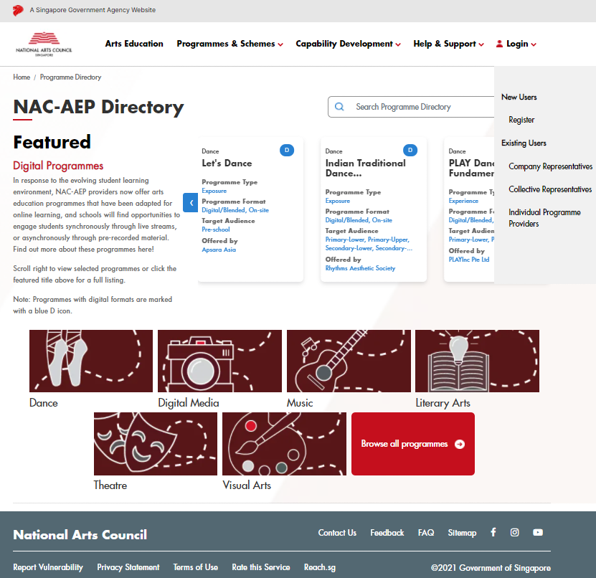
- Click on ‘Login’ and select ‘Register’.

- Select the relevant account type that you would like to register for.

In addition to Account types, take note of the following User Types applicable to Collectives and Companies:

User Type | Assignment of Admins | Admin Functions
Company | All accounts are automatically given Admin status. | Remove Users, Change other Admins into Users.
Collective | The first account associated with the Collective will be automatically assigned as the Admin. | Approve requests to join; Remove Users, Change User rights to Admins and vice versa.

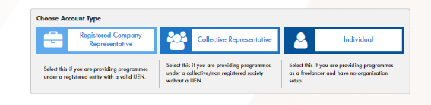
- Click on the Account Type that is relevant to you.

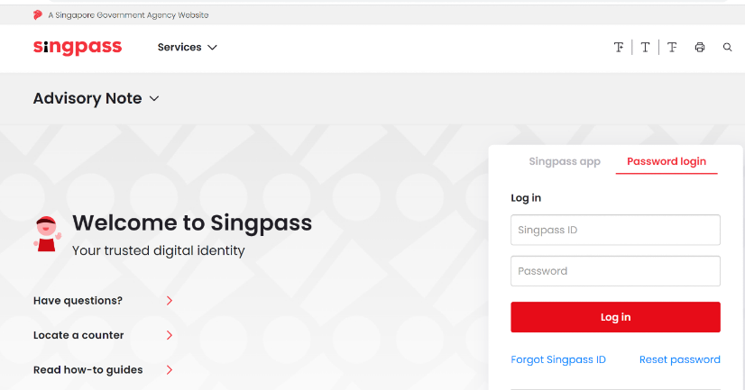
- You will be directed to login via Singpass. Key in your Singpass credentials and OTP for verification.
*NOTE* If you are logging in as a representative from a Company, ensure that your Singpass has been linked to your Company’s Corppass account.
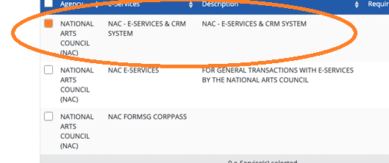

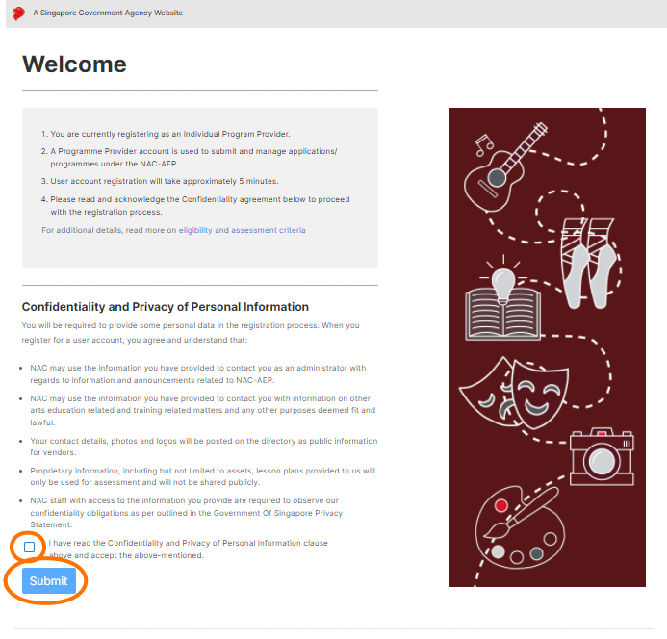
- Read the Confidentiality Agreement, check the box if you agree and understand the requirements, and click ‘Submit’.
The next steps differ according to your Account and User Type. Please refer to the section relevant to you.

Setting up your Account: Company Representatives

- To set up as a Company Representative, please ensure that your Singpass is linked to your Company’s Corppass account.

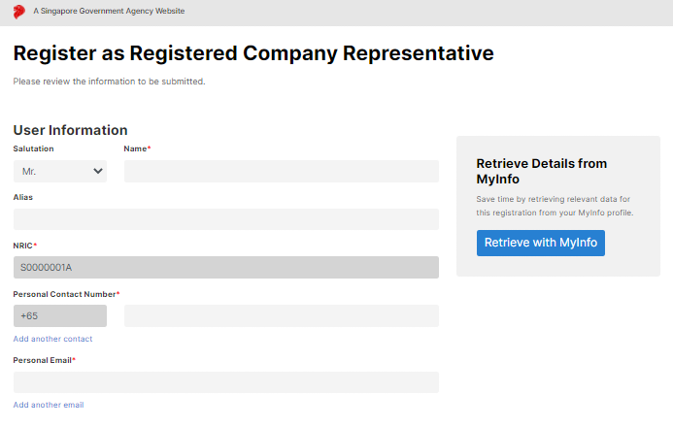
- After reading through the confidentiality Agreement, enter your personal particulars by selecting the ‘Retrieve with MyInfo’ button or key in the information manually.
- Your Company details will be automatically populated from MyInfo Business User profile/ existing records within NAC-AEP.
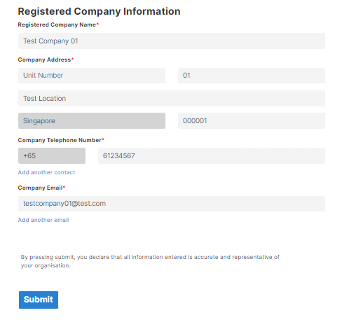
- Click ‘Submit’.
- Once complete, your account will be auto-approved and you will re-directed to your Provider Dashboard.

*NOTE* If you are registering your Company for the first time, you will be automatically assigned as the Admin.

- If you have been linked to multiple Companies, select the relevant Account and proceed with registration.

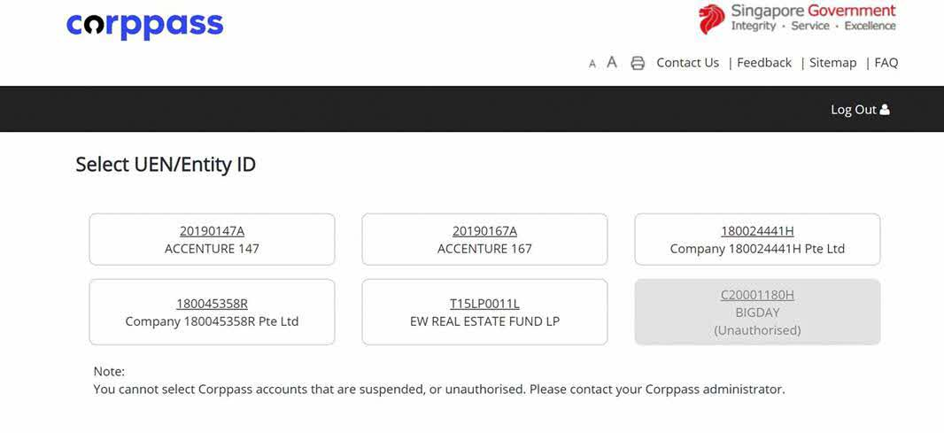
*TIP* For existing users, if you are unable to login, or do not see user/representative accounts, please do not create a new account. Instead, kindly log into the Corppass Administrator site and ensure that you have been given access specifically to the correct NAC agency, i.e; ‘NAC – ‘E-Services & CRM System’, in the CorpPass portal.

Setting up your Account: Collective Representatives

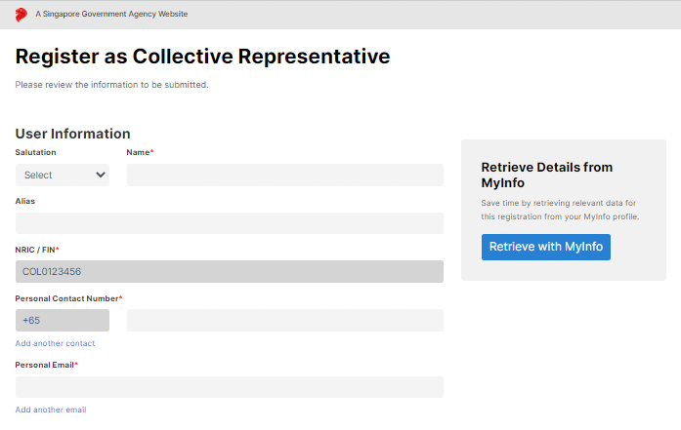
- Enter your personal particulars by selecting the ‘Retrieve with MyInfo’ button or key in the information manually.

- Enter the information for your Collective. If you are joining an existing collective, a list of Collectives will appear once you start typing in the ‘Name of Collective’ field.
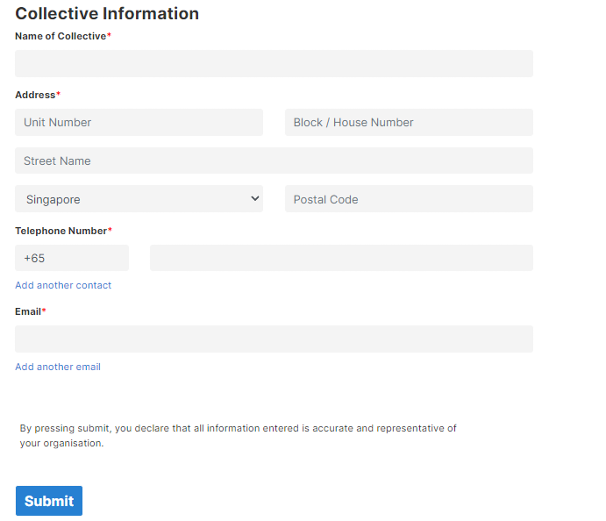

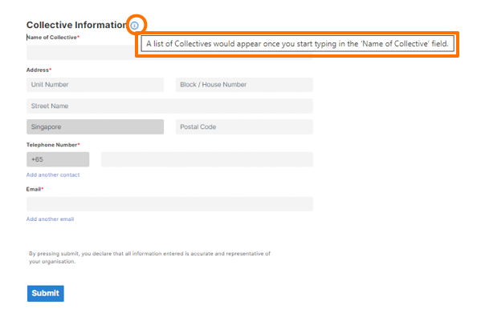
- To join an Existing Collective, select the Collective from the dropdown list. Existing details would be automatically populated. If you cannot find your Collective listed, please check with the Admin User for the registered name and Collective ID.

*NOTE* Contact the NAC Education Unit at nac_aep@nac.gov.sg if you have checked that your Collective has been registered but cannot find it listed.

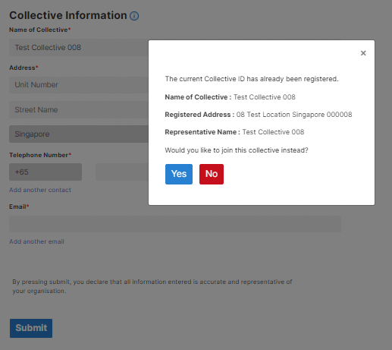
- A pop-up confirmation would appear. Select ‘Yes’ if you are sure that you are joining the correct Collective and click ‘Submit’.
- If you are registering a new Collective, please manually key in your details accurately before clicking on ‘Submit’.

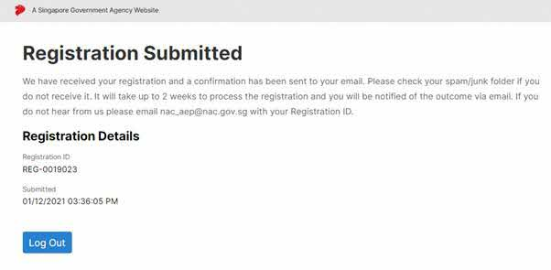
- Once complete, you will see an Acknowledgement. Click on ‘Log Out’ to return to the Registration page.

*NOTE* If you are registering your Collective for the first time, your registration will be reviewed by NAC and if successful, you will be automatically assigned as the Admin. If you have submitted a request to join an existing Collective, an existing Admin User would have to approve your application.

Setting up your Account: Individual Users

- Fill in your personal details in ‘User Information’. Your name and NRIC are auto populated by Singpass and are non-editable for security reasons.

- Enter your personal particulars by selecting the ‘Retrieve with MyInfo’ button or key in the information manually and click ‘Submit’.
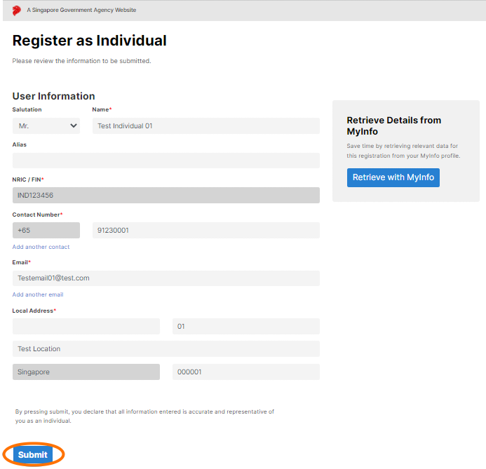

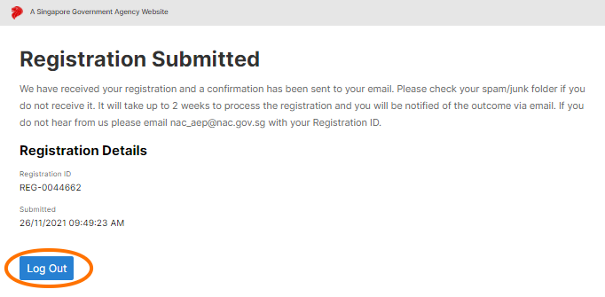
- Once completed, you will see a ‘Registration Submitted’ acknowledgement. Click on ‘Log Out’ to return to the Registration page.

Updating your Account: Registered Company / Collective Representatives

- Registered Company Representatives and Collective Representatives can edit Company/Collective profiles by clicking on the ‘Edit Company/Collective’ button.

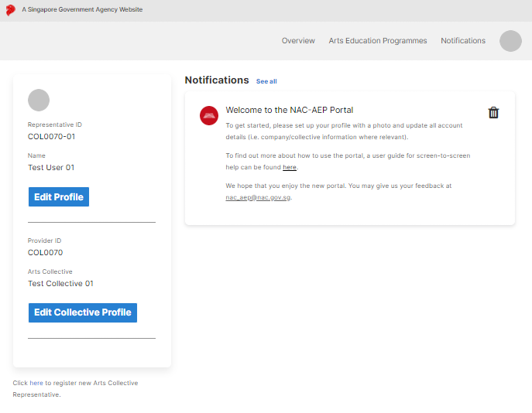
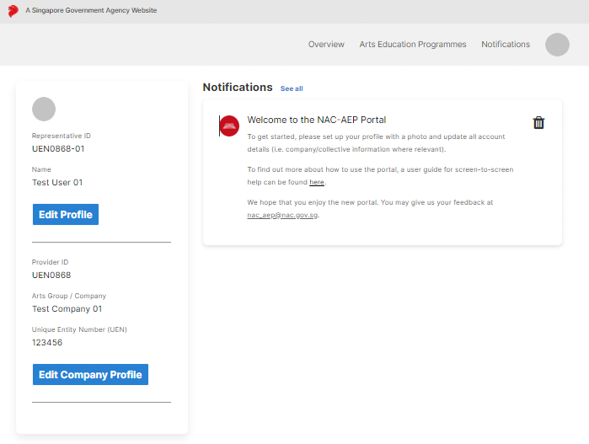
- You can update your Company/Collective particulars including registered address, contact number and email address, and provide details on your organisation.
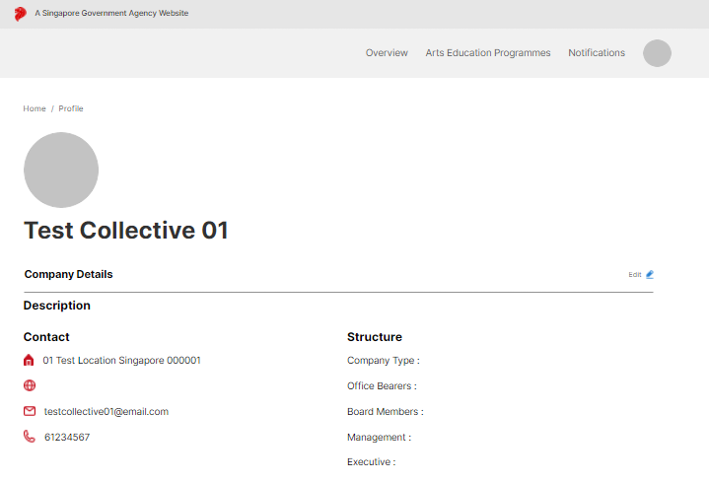
- To edit Company/Collective Details, click the ‘Edit’ icon

- Update your Company/Collective details accurately – this includes fields like “Company Type”, “Management” etc.

- Fields such as “Description” and “Website” are useful information that will be displayed on the NAC-AEP Directory if you have approved programmes.

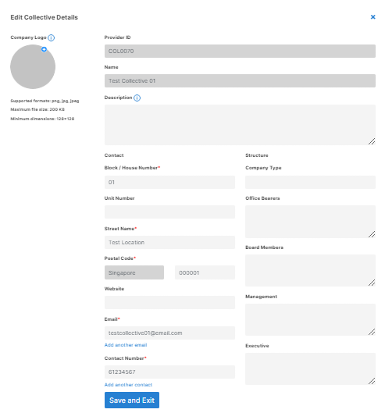
- Include a Company/Collective logo by selecting the ‘+’ button.
*TIP* Refresh the page if you do not see your profile photo or logo uploaded.
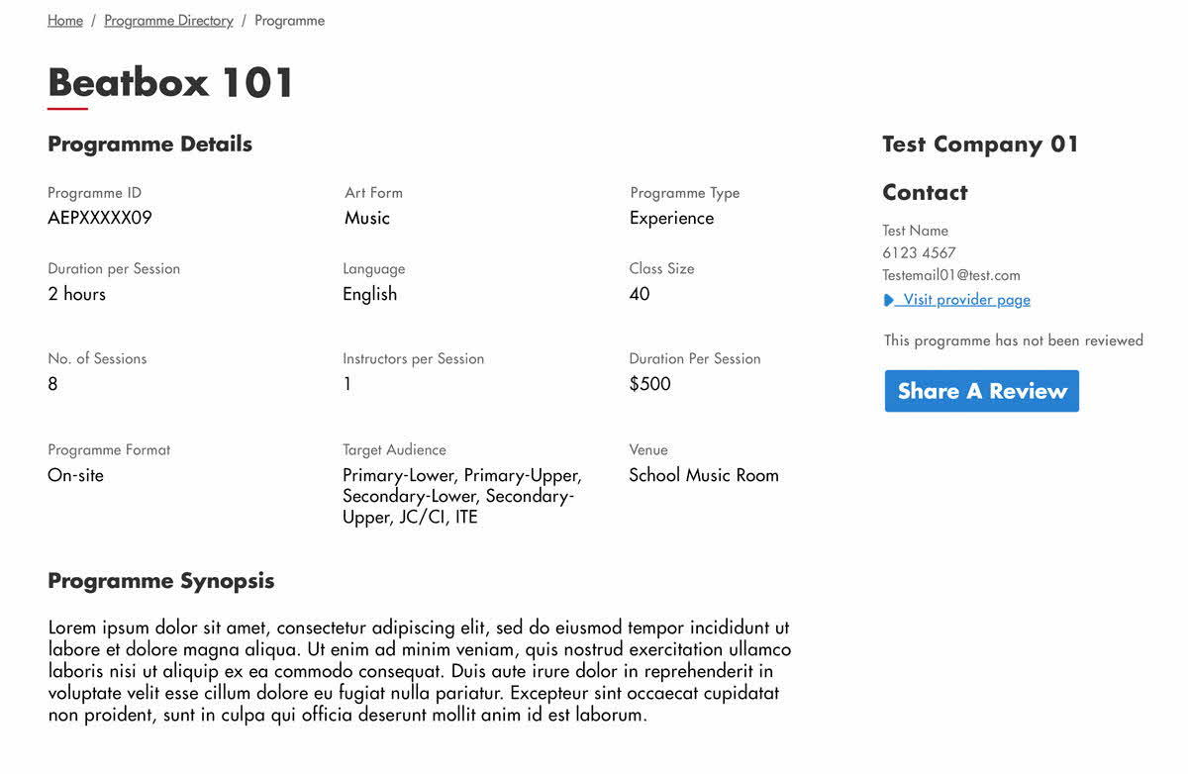
- Your Company/Collective description and website will be published alongside your programme listing on the Programme Directory (see orange box).

Updating your Account: Individual Users

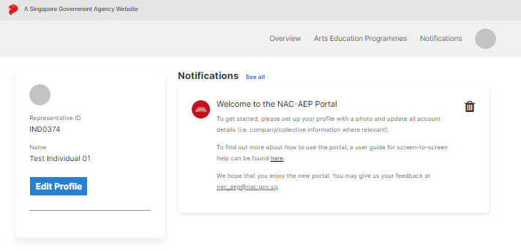
  - Click on ‘Edit Profile’ on the left panel of the Dashboard to access all your account information. You can also access your account by clicking on the circle on the top bar.
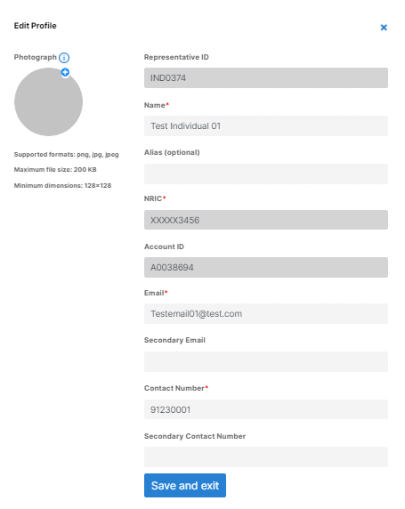
  - Update your Profile and include a Profile picture by selecting the ‘+’ button. Your name and NRIC is auto populated by Singpass and is non-editable for security reasons.
*TIP* Refresh the page if you do not see your profile photo or logo uploaded.
  - Enter your alias in the “Alias” field if you would like to display your alias over your registered name in NAC-AEP Directory.

  - Your Company/Collective details will be published alongside your programme listing on the Programme Directory (see orange box).

Managing Multiple Accounts

In some instances, Individuals may be linked to multiple entities. For example, you might be managing NAC-AEP as a sole proprietor whilst being part of a Collective. It is possible to hold multiple accounts under one Singpass ID.

  - If your Singpass is linked to multiple entities, you can switch your accounts by clicking on ‘Switch Account’ on the Dashboard.

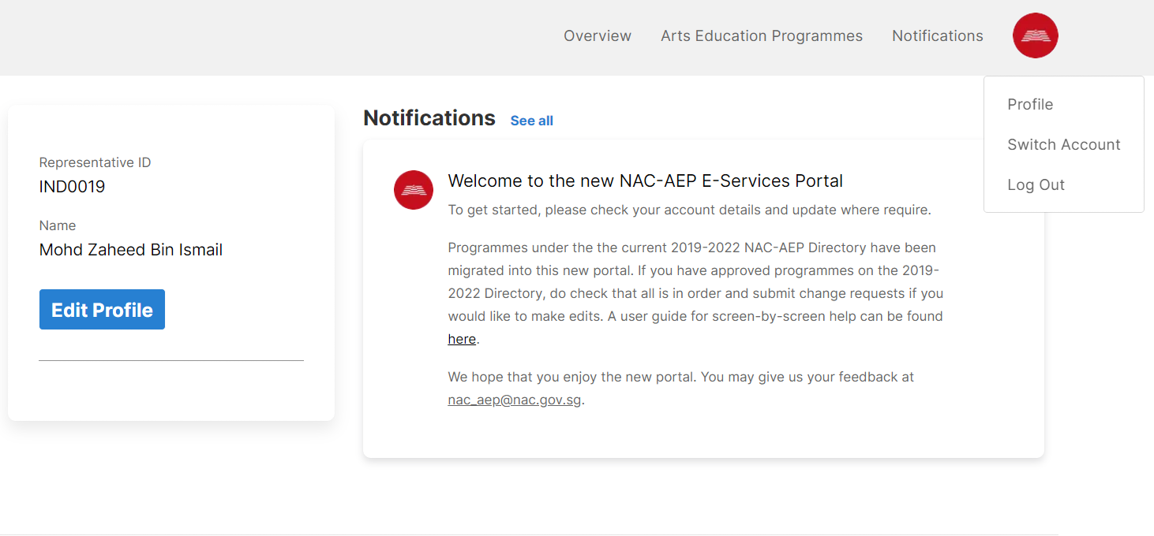

  - Select the Account that you would like to switch to.
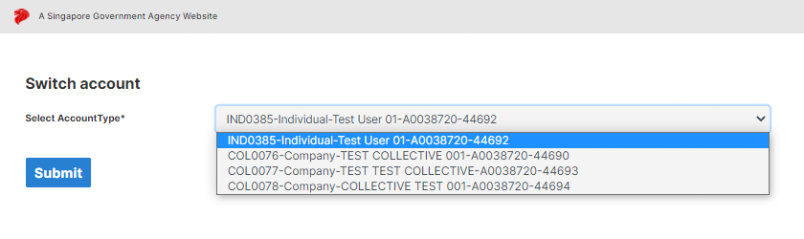

Withdrawing Accounts
If you need to withdraw an account from your company/collective profile, please follow these steps.
  - Head to your profile page, under the Account Permissions section, click on the ‘delete’ icon located on the top right-hand corner of representative profile tile.
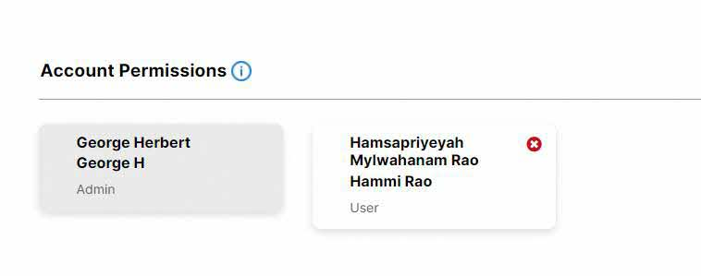
  - Click ‘Yes’ on the confirmation box to withdraw that account.
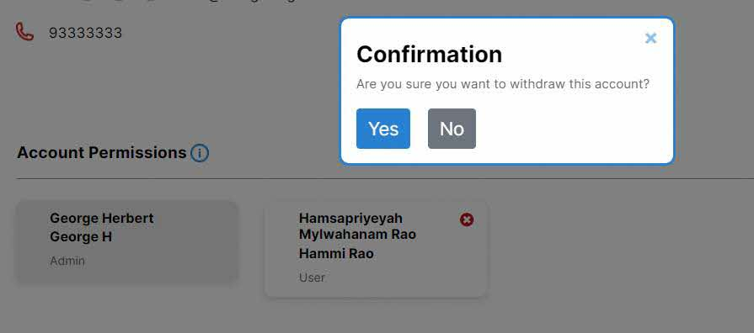

*NOTE* If you are an Admin and wish to completely deactivate the account, you may contact the NAC Education Unit at nac_aep@nac.gov.sg, and we will deactivate the account for you.

If you encounter an issue not covered in this Guide, you may contact the NAC Education Unit at nac_aep@nac.gov.sg. To help us better understand your issue, please provide screenshots where relevant.

